Artistverse
Software Design Development
Nichakamol  Watcharit | Sanghong 642115015
 | Srichai | 642115041
Bachelor of Science
Software Engineering Program
Department College of Arts, Media, and
Technology
Chiang Mai University
October 2024
Project Advisor
Asst. Prof. Pattama Longani, Ph.D.

Document History
Document  Name | Version | History | Status | Date | Editable | Reviewer
Artistverse-  SDD | Artistverse-  SDD V.0.1 | Add Chapter1  • Purpose and  Scope  • User  Characteristics  • Acronyms andDefinitions AddChapter2  • Software  Architecture  AddChapter3  Progress1  • Detail Design  • Class Diagram• Sequence  Diagram  Add Chapter 4  Progress1  • UI | Draft | 13/05/2024 | NS | PL
Artistverse-  SDD | Artistverse-  SDD V.0.2 | Edit Chapter3  Progress1  • Detail Design  • Class Diagram• Sequence  Diagram  Edit Chapter 4  Progress1  • UI | Edit | 11/06/2024 | NS, WS | PL
Artistverse-  SDD | Artistverse-  SDD V.0.3 | Edit Chapter3  Progress1  • Detail Design  • Class Diagram• Sequence  Diagram | Edit | 14/06/2024 | NS, WS | PL

Document  Name | Artistverse-SDD V.3.0 | Owner | NS , WS | Page | 2
Document  Type | Software Design  Development | Release Date | 11/10/2024 | Print date | 11/10/2024

Artistverse-  SDD | Artistverse-  SDD V.0.4 | Edit Chapter3  Progress1  • Detail Design  • Class Diagram• Sequence  Diagram | Edit | 24/06/2024 | NS, WS | PL
Artistverse-  SDD | Artistverse-  SDD V.1.0 | Edit Chapter3  Progress1  • Detail Design  • Class Diagram• Class DiagramDescription  • Sequence  Diagram | Edit | 28/06/2024 | NS, WS | PL
Artistverse-  SDD | Artistverse-  SDD V.1.1 | Add Chapter3  Add Progress2  • Detail Design  • Class Diagram• Class DiagramDescription  • Sequence  Diagram | Draft | 15/08/2024 | NS, WS | PL
Artistverse-  SDD | Artistverse-  SDD V.1.2 | Edit Chapter3  Add Progress2  • Detail Design  • Class Diagram• Class DiagramDescription  • Sequence  Diagram | Edit | 20/08/2024 | NS, WS | PL
Artistverse-  SDD | Artistverse-  SDD V.1.3 | Add Chapter3  Add Progress2  • Detail Design  • Class Diagram• Class DiagramDescription  • Sequence  Diagram | Edit | 25/08/2024 | NS, WS | PL

Document  Name | Artistverse-SDD V.3.0 | Owner | NS , WS | Page | 3
Document  Type | Software Design  Development | Release Date | 11/10/2024 | Print date | 11/10/2024

Artistverse-  SDD | Artistverse-  SDD V.2.0 | Add Chapter3  Add Progress2  • Detail Design  • Class Diagram• Class DiagramDescription  • Sequence  Diagram | Publis  h | 30/08/2024 | NS, WS | PL
Artistverse-  SDD | Artistverse-  SDD V.3.0 | Publish  document  version 3.0 | Publis  h | 11/10/2024 | NS, WS | PL
a
Document  Name | Artistverse-SDD V.3.0 | Owner | NS , WS | Page | 4
Document  Type | Software Design  Development | Release Date | 11/10/2024 | Print date | 11/10/2024

Chapter 1 Introduction
1.1 Purpose and Scope
The purpose of the software design development is to present a complete software design of
the Artistverse project. This document contains the outline of the software architecture,
functions used, and activity diagrams with the user interface for this project.
1.2 User Characteristics
User | Role
Songwriter | A person who logs in to the Artistverse system and uses the system
1.3 Acronyms and Definitions
Acronyms
SRS | Software Requirement Specification
UI | User Interface
SDD | Software Design Document
FD | Function Description

Document  Name | Artistverse-SDD V.3.0 | Owner | NS , WS | Page | 5
Document  Type | Software Design  Development | Release Date | 11/10/2024 | Print date | 11/10/2024

Definition
Name | Definition
IEEE | Institute for Electrical and Electronics Engineers. Biggest global interest  group for engineers of different branches and computer scientists. [1]
Plan | A document series of tasks requires meeting an objective, typically  including the associated schedule, budget, resources, organizational  description and work breakdown structure. [1]
Feature | Feature Transformation of input parameters to output parameters based  on a specified algorithm. It describes the functionality of the product in  the language of the product. Used for requirements analysis, design,  coding, testing or maintenance. [1]
Project  Management | The application of knowledge, skills, tools, and techniques to project  activities in order to meet or exceed stakeholder needs and expectations  from a project. [1]
Project Plan | A formal, approved document used to guide both project execution and  project control. The primary uses of the project plan are to document  planning assumptions and the decision, to facilitate communication  among stakeholders, and to document approved scope, cost, and  schedule baseline. [1]
Risk | An uncertain event or condition that, if it occurs, has a positive or  negative effect on a project’s objectives. It is a function of the  probability of occurrence of a given threat’s occurrence. [1]
Risk  Management | The systematic application of management policies, procedures and  practices to the tasks of identifying, analyzing, evaluating, treating and  monitoring risk. [1]
System Testing | Testing conducted on a complete and integrated system for evaluate the  system’s compliance with its specified requirements. [1]
Unit Test | A test of individual programs or modules in order to remove a design or  programming errors. [1]

Document  Name | Artistverse-SDD V.3.0 | Owner | NS , WS | Page | 6
Document  Type | Software Design  Development | Release Date | 11/10/2024 | Print date | 11/10/2024

Traceability | The ability to trace the history, application or location of an item or  activity, or work products or activities, by means of recorded  identification. The establishment and maintenance of relationships  between such items. Horizontal traceability describes the relationship  between work products of the same type (e.g. Customer requirements).  Vertical traceability describes the relationship between work products,  which build or derived from each other (e.g., from customer  requirements to qualification test cases). Bidirectional traceability  allows to directly following relationships in both directions. [1]
Use Case | A use case is a description of a specific interaction between a system  and its users to accomplish a particular goal or task. It outlines the  sequence of steps or actions that a user performs in the system and  describes the system's responses to those actions. Use cases help to  identify and define the functional requirements of a system from the  perspective of its users.

Document  Name | Artistverse-SDD V.3.0 | Owner | NS , WS | Page | 7
Document  Type | Software Design  Development | Release Date | 11/10/2024 | Print date | 11/10/2024

Chapter 2 System Architecture
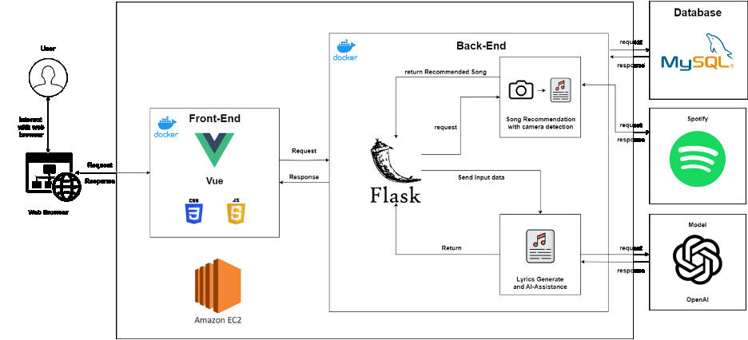
The user (Musician/Songwriter/Beginning songwriter) will be able to access the
website front-end that was built by using Vue.js, a lightweight Python web framework calledFlask, and Docker for containerization. The front-end allows users to create interactive webapplications using reactive data binding and components. The back end enables us to createweb applications by defining routes and handling requests and responses. Docker allows us topackage our application and its dependencies into a single, portable container, ensuring easydeployment and running on any platform that supports Docker. We used the OpenAI modelfor the function-generated lyrics and Ai-Assistance to get the return result of the lyricsgenerated and the question-answer based on the user input. Spotify Api is for getting a list ofthe songs to use in the function song recommendation. The MySQL database stores input,lyrics, and other relevant information, which is used to retrieve song lyrics and other datawhen generating recommendations
Document  Name | Artistverse-SDD V.3.0 | Owner | NS , WS | Page | 8
Document  Type | Software Design  Development | Release Date | 11/10/2024 | Print date | 11/10/2024

Chapter 3 Detail Design
3.1 Progress I
3.1.1 Class Diagram
3.1.1.1 Feature #1: Dynamic Lyric Composition
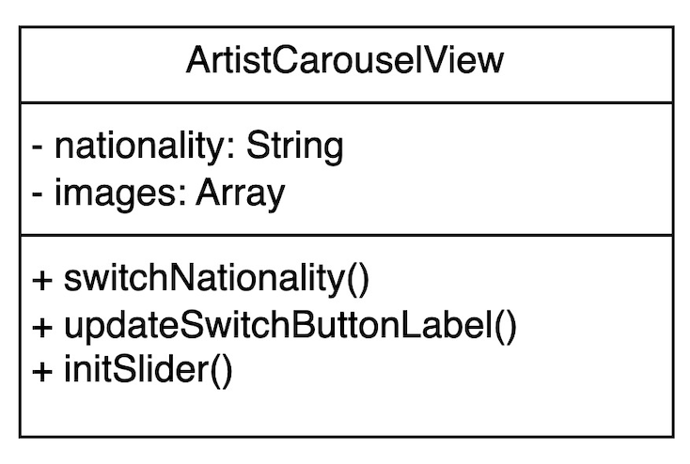
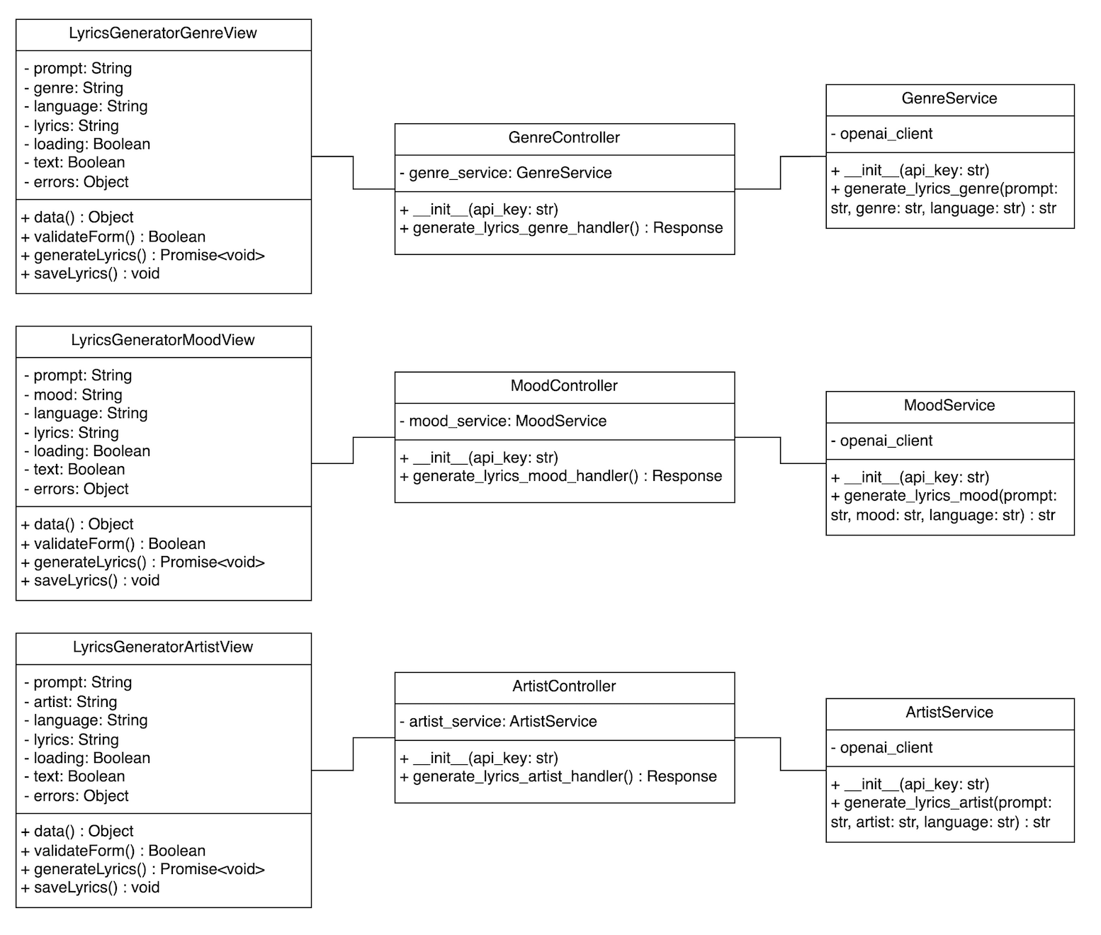
Document  Name | Artistverse-SDD V.3.0 | Owner | NS , WS | Page | 9
Document  Type | Software Design  Development | Release Date | 11/10/2024 | Print date | 11/10/2024

3.1.1.2 Feature #2: Mood Detection Camera Integration
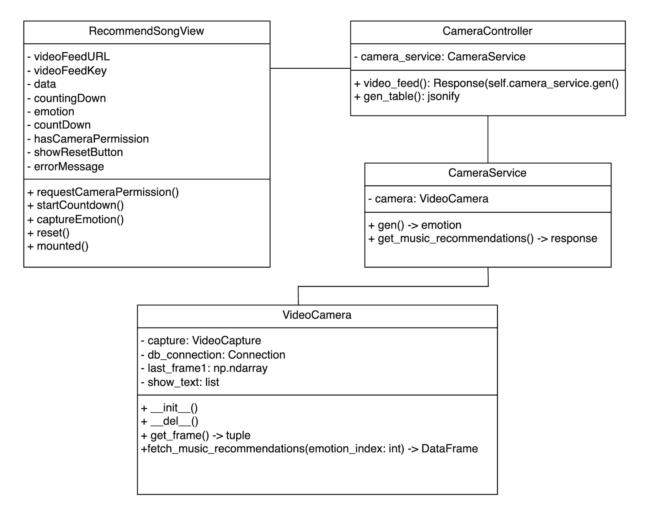
Document  Name | Artistverse-SDD V.3.0 | Owner | NS , WS | Page | 10
Document  Type | Software Design  Development | Release Date | 11/10/2024 | Print date | 11/10/2024

3.1.2 Class Diagram Description
3.1.2.1 Views
3.1.2.1.1 Views: ArtistCarouselView

Attributes:
ID | Name | Description | Type
1 | Nationality | A string representing the currentnationality of the artist. | String
2 | Images | An array containing objects withinformation about artists' imagesincluding source, description,  nationality, and popup status. | Array
Methods:
ID | Name | Description | Parameter | Return Type
1 | switchNationality() | The function used  to switch the  display between  Thai and  international artists | selectedNationality (String): The  new nationality toswitch to. | void

Document  Name | Artistverse-SDD V.3.0 | Owner | NS , WS | Page | 11
Document  Type | Software Design  Development | Release Date | 11/10/2024 | Print date | 11/10/2024

2 | updateSwitchButtonLabel() | The function used  to adjust the text onthe display toggle  button. | newLabel  (String): The newlabel to set for thebutton. | void
3 | initSlider() | Initializes the imageslider for the artist'simages | None | void

Document  Name | Artistverse-SDD V.3.0 | Owner | NS , WS | Page | 12
Document  Type | Software Design  Development | Release Date | 11/10/2024 | Print date | 11/10/2024

3.1.2.1.2 Views: LyricsGeneratorGenreView
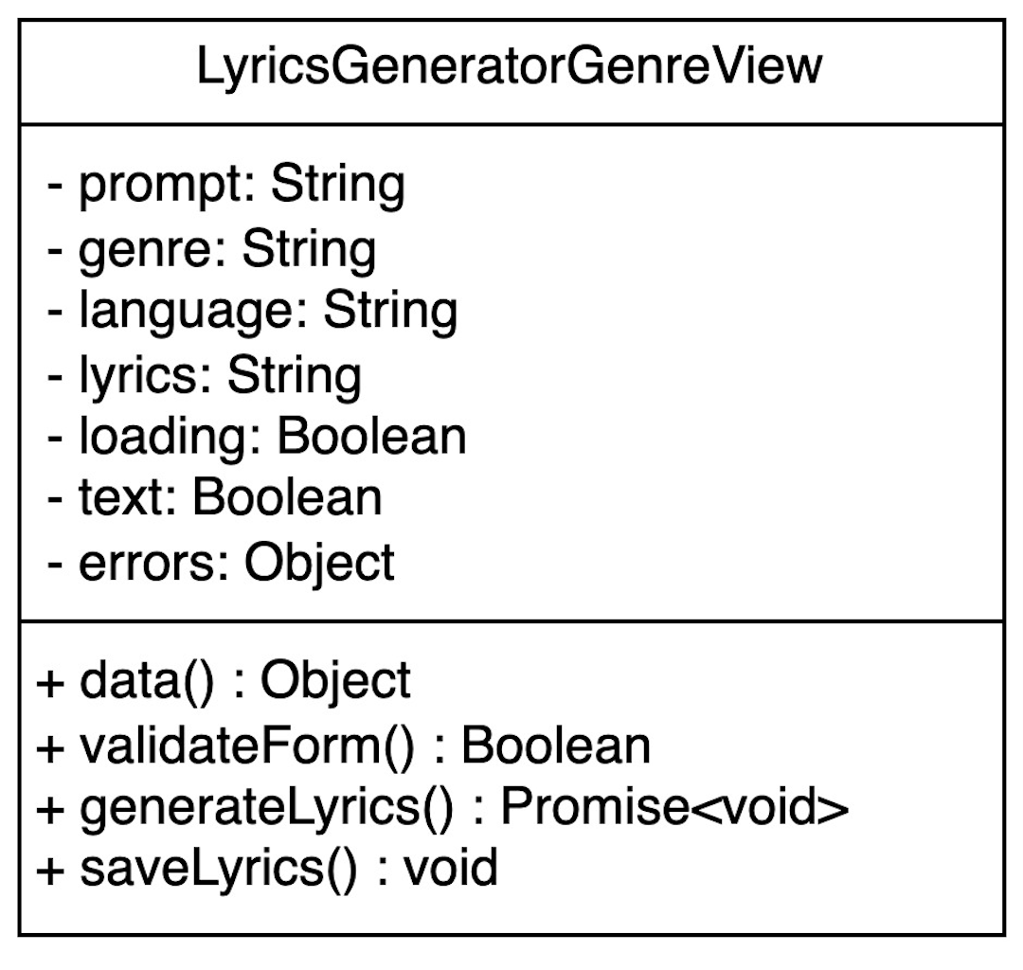
Attributes:
ID | Name | Description | Type
1 | prompt | The topic or theme for the  lyrics that the user inputs | String
2 | genre | Dropdown selection for the  genre of the lyrics | String
3 | language | Dropdown selection for the  language in which the lyrics arewritten | String
4 | lyrics | Text area where the generatedlyrics are displayed | String
5 | loading | Boolean flag indicating if thelyrics generation is in progress | Boolean
6 | text | Boolean flag indicating if textinput is active | Boolean
7 | errors | Object containing error  messages related to the form  inputs | Object

Document  Name | Artistverse-SDD V.3.0 | Owner | NS , WS | Page | 13
Document  Type | Software Design  Development | Release Date | 11/10/2024 | Print date | 11/10/2024

Methods:
ID | Name | Description | Parameter | Return Type
1 | data() | Retrieves the current  state data of the form,  including user inputs  and errors | None | Object
2 | validateForm() | Validates the form  inputs to ensure all  required fields are filledout correctly | None | Boolean
3 | generateLyrics() | Initiates the lyrics  generation process  based on the provided  form inputs | None | Promise<void>
4 | saveLyrics() | Saves the generated  lyrics to the songwriter'slocal computer in a .txtfile format | None | void

Document  Name | Artistverse-SDD V.3.0 | Owner | NS , WS | Page | 14
Document  Type | Software Design  Development | Release Date | 11/10/2024 | Print date | 11/10/2024

3.1.2.1.3 Views: LyricsGeneratorMoodView
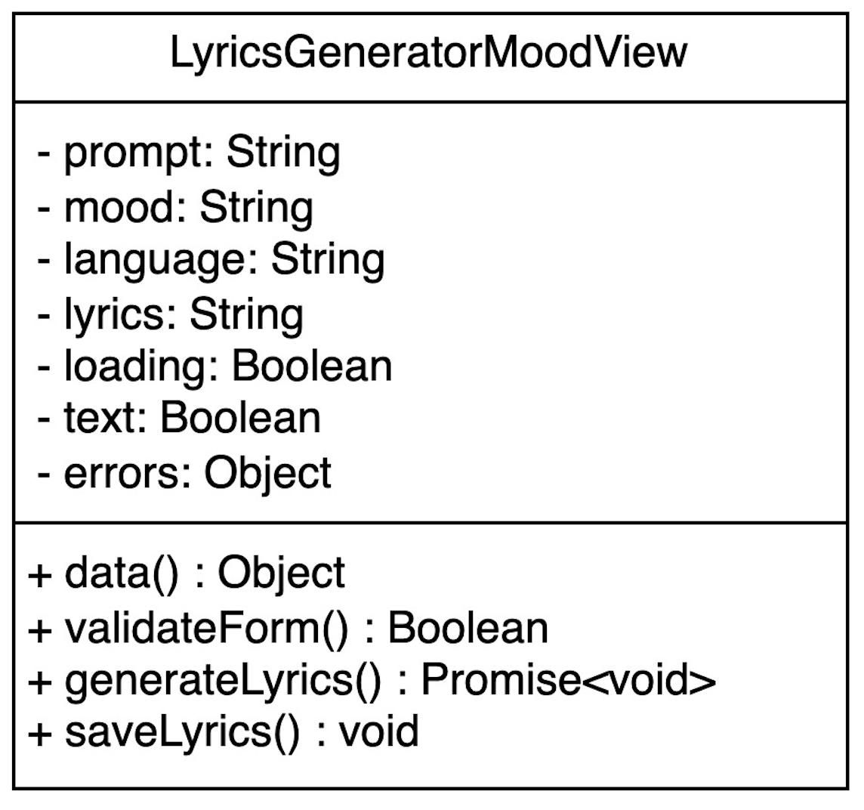
Attributes:
ID | Name | Description | Type
1 | prompt | The topic or theme for the  lyrics that the user inputs | String
2 | mood | Dropdown selection for the  mood of the lyrics | String
3 | language | Dropdown selection for the  language in which the lyrics arewritten | String
4 | lyrics | Text area where the generatedlyrics are displayed | String
5 | loading | Boolean flag indicating if thelyrics generation is in progress | Boolean
6 | text | Boolean flag indicating if textinput is active | Boolean
7 | errors | Object containing error  messages related to the form  inputs | Object

Document  Name | Artistverse-SDD V.3.0 | Owner | NS , WS | Page | 15
Document  Type | Software Design  Development | Release Date | 11/10/2024 | Print date | 11/10/2024

Methods:
ID | Name | Description | Parameter | Return Type
1 | data() | Retrieves the current  state data of the form,  including user inputs  and errors | None | Object
2 | validateForm() | Validates the form  inputs to ensure all  required fields are filledout correctly | None | Boolean
3 | generateLyrics() | Initiates the lyrics  generation process  based on the provided  form inputs | None | Promise<void>
4 | saveLyrics() | Saves the generated  lyrics to the songwriter'slocal computer in a .txtfile format | None | void

Document  Name | Artistverse-SDD V.3.0 | Owner | NS , WS | Page | 16
Document  Type | Software Design  Development | Release Date | 11/10/2024 | Print date | 11/10/2024

3.1.2.1.4 Views: LyricsGeneratorArtistView
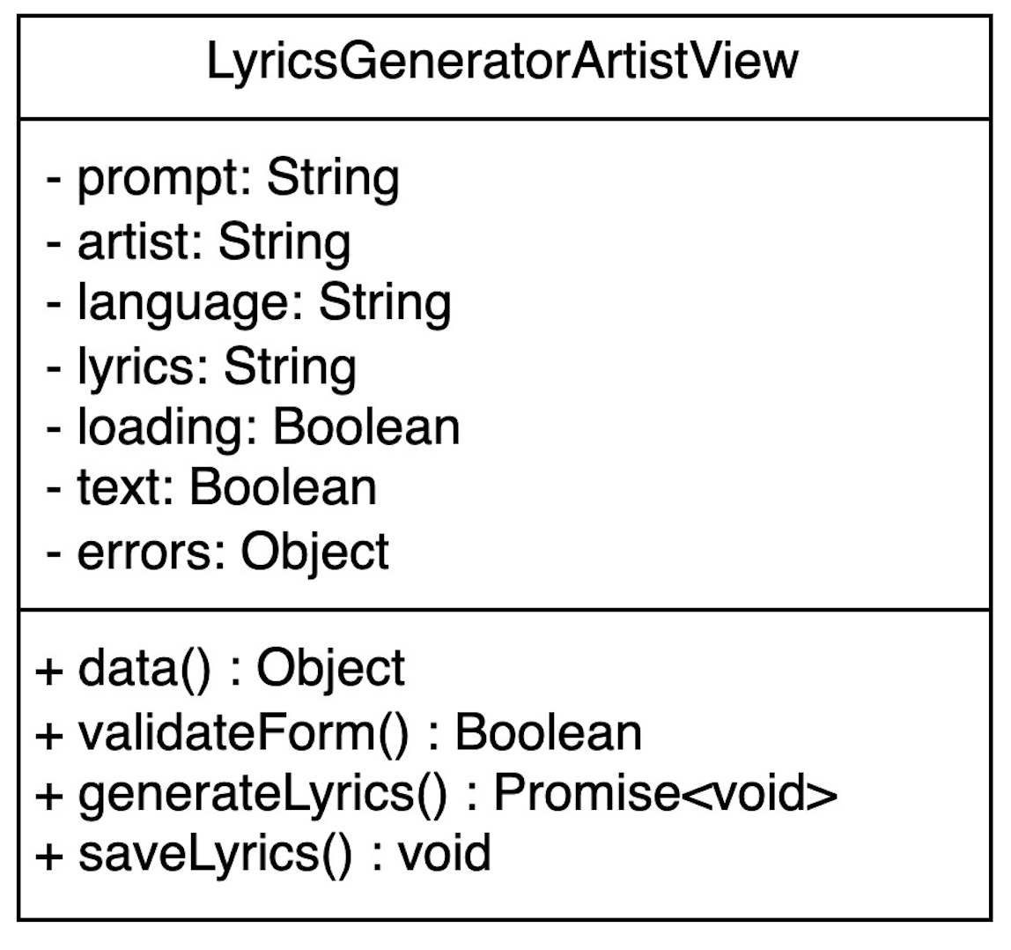
Attributes:
ID | Name | Description | Type
1 | prompt | The topic or theme for the  lyrics that the user inputs | String
2 | artist | Dropdown selection for the  artist style of the lyrics | String
3 | language | Dropdown selection for the  language in which the lyrics arewritten | String
4 | lyrics | Text area where the generatedlyrics are displayed | String
5 | loading | Boolean flag indicating if thelyrics generation is in progress | Boolean
6 | text | Boolean flag indicating if textinput is active | Boolean
7 | errors | Object containing error  messages related to the form  inputs | Object

Document  Name | Artistverse-SDD V.3.0 | Owner | NS , WS | Page | 17
Document  Type | Software Design  Development | Release Date | 11/10/2024 | Print date | 11/10/2024

Methods:
ID | Name | Description | Parameter | Return Type
1 | data() | Retrieves the current  state data of the form,  including user inputs  and errors | None | Object
2 | validateForm() | Validates the form  inputs to ensure all  required fields are filledout correctly | None | Boolean
3 | generateLyrics() | Initiates the lyrics  generation process  based on the provided  form inputs | None | Promise<void>
4 | saveLyrics() | Saves the generated  lyrics to the songwriter'slocal computer in a .txtfile format | None | void

Document  Name | Artistverse-SDD V.3.0 | Owner | NS , WS | Page | 18
Document  Type | Software Design  Development | Release Date | 11/10/2024 | Print date | 11/10/2024

3.1.2.1.5 Views: RecommendSongView
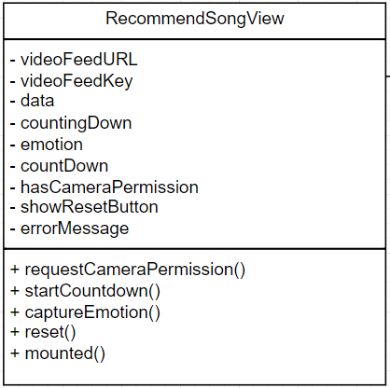
Attributes:
ID | Name | Description | Type
1 | videoFeedURL | The topic or theme for the  lyrics that the user inputs | string
2 | videoFeedKey | Key for the video feed | int
3 | data | List of song recommendations | array
4 | countingDown | Indicates if countdown is active | boolean
5 | emotion | Detected emotion | string
6 | countDown | Countdown timer value | int
7 | hasCameraPermission | Indicates if camera permissionis granted | boolean
8 | showResetButton | Indicates if reset button shouldbe shown | boolean

Document  Name | Artistverse-SDD V.3.0 | Owner | NS , WS | Page | 19
Document  Type | Software Design  Development | Release Date | 11/10/2024 | Print date | 11/10/2024

9 | errorMessage | Error message for mood  detection | string
Methods:
ID | Name | Description | Parameter | Return Type
1 | requestCameraPermission | For requests camera  permission | None | void
2 | startCountdown | Starts the countdown foremotion detection | None | void
3 | captureEmotion | Captures the Songwriteremotion and fetches  song recommendations | None | void
4 | reset | Resets the state | None | void
5 | mounted | Lifecycle hook to  request camera  permission on mount | None | void

Document  Name | Artistverse-SDD V.3.0 | Owner | NS , WS | Page | 20
Document  Type | Software Design  Development | Release Date | 11/10/2024 | Print date | 11/10/2024

3.1.2.2 Controller
3.1.2.2.1 Controller: GenreController
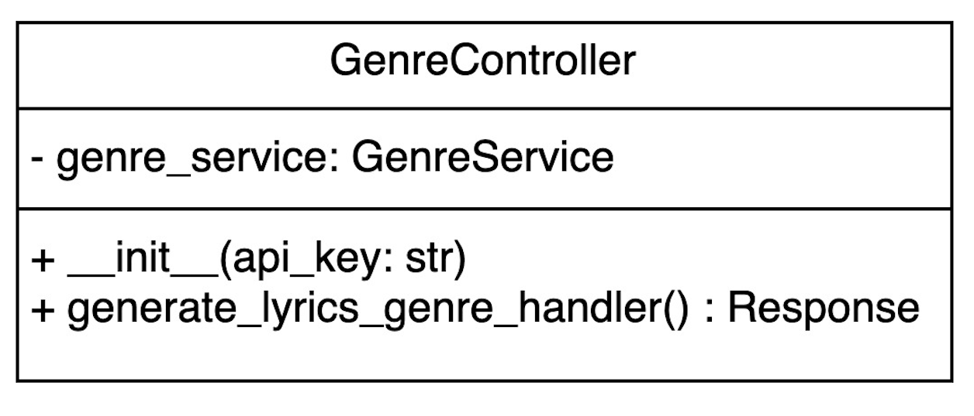
Attributes:
ID | Name | Description | Type
1 | genre_service | An instance of GenreService  used to handle operations  related to genres | GenreService
Methods:
ID | Name | Description | Parameter | Return Type
1 | init(api_key: str) | Initializes the controllerwith the necessary APIkey to access the genreservice | api_key: str | Response
2 | generate_lyrics_genre_handler() | Handles the request to  generate lyrics based onthe provided genre | None | Response

Document  Name | Artistverse-SDD V.3.0 | Owner | NS , WS | Page | 21
Document  Type | Software Design  Development | Release Date | 11/10/2024 | Print date | 11/10/2024

3.1.2.2.2 Controller: MoodController
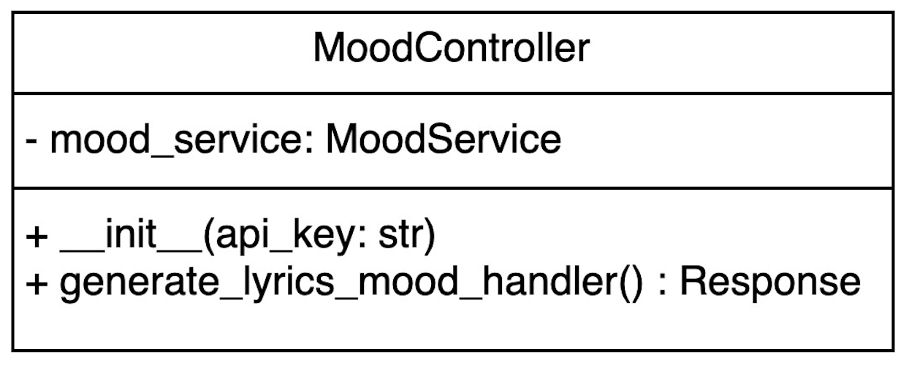
Attributes:
ID | Name | Description | Type
1 | mood_service | An instance of MoodService  used to handle operations  related to moods | MoodService
Methods:
ID | Name | Description | Parameter | Return Type
1 | init(api_key: str) | Initializes the controllerwith the necessary APIkey to access the moodservice | api_key: str | Response
2 | generate_lyrics_mood_handler() | Handles the request to  generate lyrics based onthe provided mood | None | Response

Document  Name | Artistverse-SDD V.3.0 | Owner | NS , WS | Page | 22
Document  Type | Software Design  Development | Release Date | 11/10/2024 | Print date | 11/10/2024

3.1.2.2.2 Controller: ArtistController
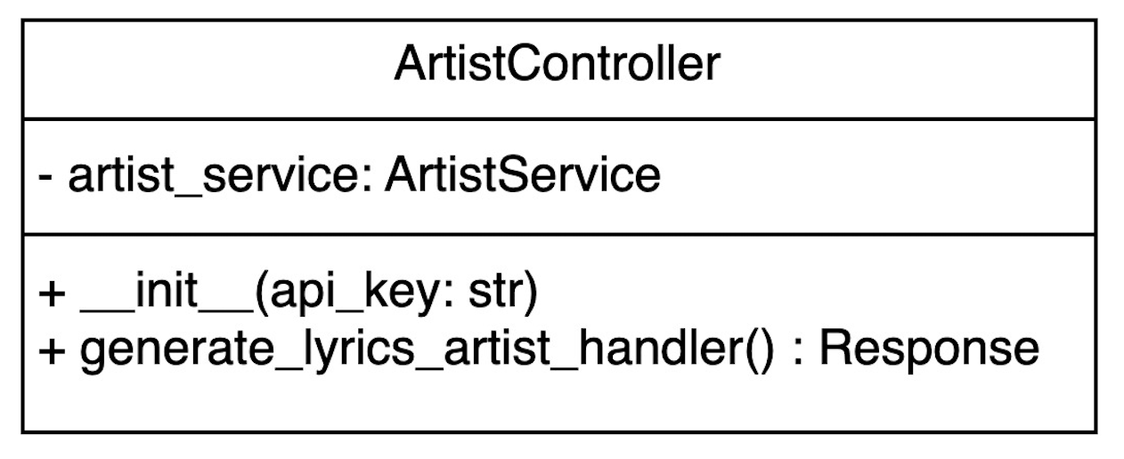
Attributes:
ID | Name | Description | Type
1 | artist_service | An instance of ArtistService  used to handle operations  related to artists | ArtistService
Methods:
ID | Name | Description | Parameter | Return Type
1 | init(api_key: str) | Initializes the controllerwith the necessary APIkey to access the artist  service | api_key: str | Response
2 | generate_lyrics_artist_handler() | Handles the request to  generate lyrics based onthe provided artist style | None | Response

Document  Name | Artistverse-SDD V.3.0 | Owner | NS , WS | Page | 23
Document  Type | Software Design  Development | Release Date | 11/10/2024 | Print date | 11/10/2024

3.1.2.2.4 Controller: CameraController
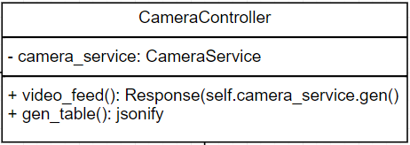
Attributes:
ID | Name | Description | Type
1 | camera_service | Instance of CameraService | CameraService
Methods:
ID | Name | Description | Parameter | Return Type
1 | video_feed | Provides the video  feed response | None | Response(self.camera_service.gen()
2 | gen_table | Generates a JSON  response with musicrecommendations | None | jsonify

Document  Name | Artistverse-SDD V.3.0 | Owner | NS , WS | Page | 24
Document  Type | Software Design  Development | Release Date | 11/10/2024 | Print date | 11/10/2024

3.1.2.3 Service
3.1.2.3.1 Service: GenreService
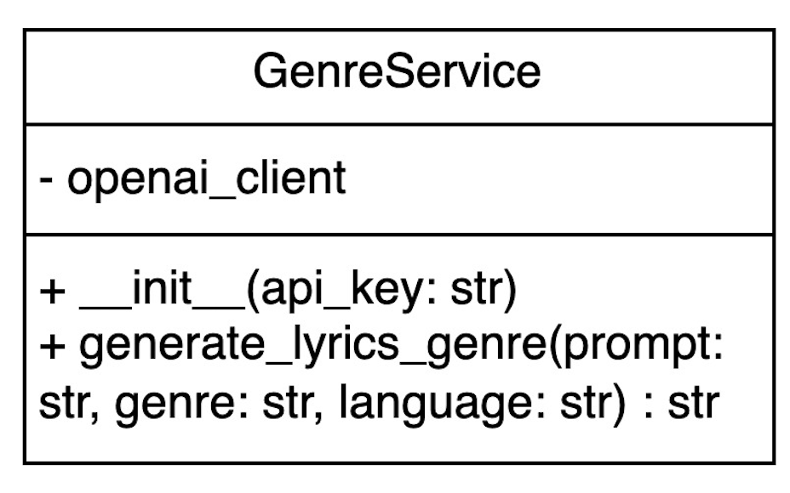
Attributes:
ID | Name | Description | Type
1 | openai_client | Client for OpenAI API | OpenAI Client
Methods:
ID | Name | Description | Parameter | Return Type
1 | init(api_key: str) | Initialize with API  key | api_key: str | None
2 | generate_lyrics_genre(prompt: str,  genre: str,  language: str) | Generate lyrics  based on genre | prompt: str,  genre: str,  language: str | str

Document  Name | Artistverse-SDD V.3.0 | Owner | NS , WS | Page | 25
Document  Type | Software Design  Development | Release Date | 11/10/2024 | Print date | 11/10/2024

3.1.2.3.2 Service: MoodService
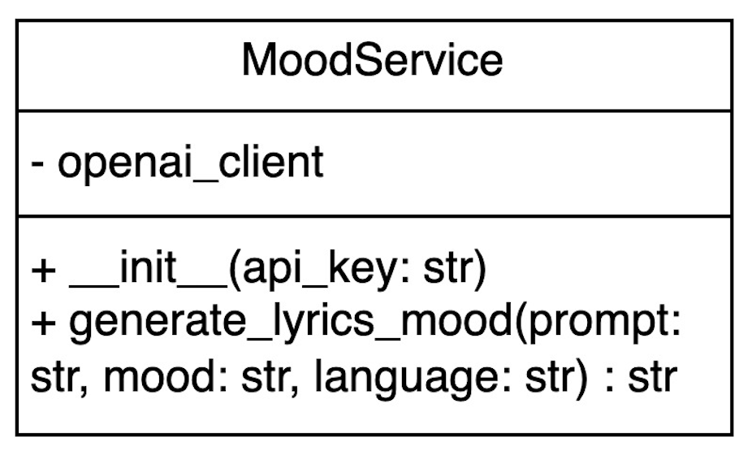
Attributes:
ID | Name | Description | Type
1 | openai_client | Client for OpenAI API | OpenAI Client
Methods:
ID | Name | Description | Parameter | Return Type
1 | init(api_key: str) | Initialize with API  key | api_key: str | None
2 | generate_lyrics_mood(prompt: str,  mood: str,  language: str) | Generate lyrics  based on mood | prompt: str,  mood: str,  language: str | str

Document  Name | Artistverse-SDD V.3.0 | Owner | NS , WS | Page | 26
Document  Type | Software Design  Development | Release Date | 11/10/2024 | Print date | 11/10/2024

3.1.2.3.3 Service: ArtistService
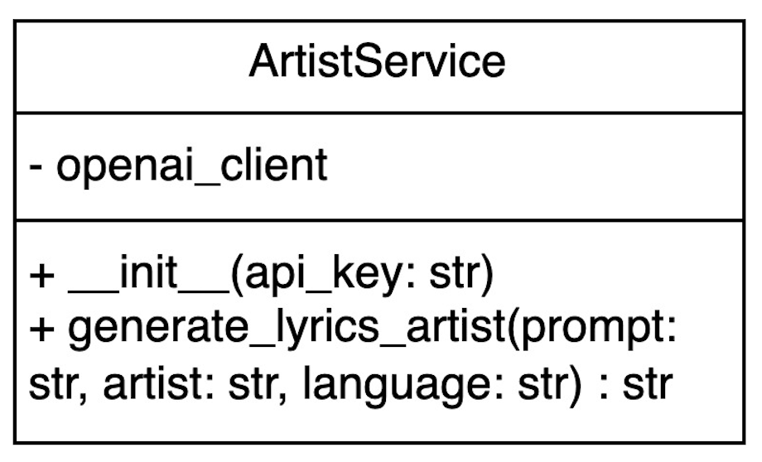
Attributes:
ID | Name | Description | Type
1 | openai_client | Client for OpenAI API | OpenAI Client
Methods:
ID | Name | Description | Parameter | Return Type
1 | init(api_key: str) | Initialize with API  key | api_key: str | None
2 | generate_lyrics_artist(prompt: str,  artist: str,  language: str) | Generate lyrics  based on artist style | prompt: str,  artist: str,  language: str | str

Document  Name | Artistverse-SDD V.3.0 | Owner | NS , WS | Page | 27
Document  Type | Software Design  Development | Release Date | 11/10/2024 | Print date | 11/10/2024

3.1.2.2.4 Service: CameraService
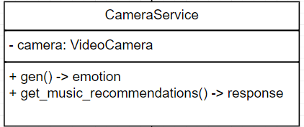
Attributes:
ID | Name | Description | Type
1 | camera | Instance of VideoCamera | VideoCamera
Methods:
ID | Name | Description | Parameter | Return Type
1 | gen | Generates video frameswith emotion detection | None | emotion
2 | get_music_recommendations | Fetches music  recommendations basedon detected emotions | None | response

Document  Name | Artistverse-SDD V.3.0 | Owner | NS , WS | Page | 28
Document  Type | Software Design  Development | Release Date | 11/10/2024 | Print date | 11/10/2024

3.1.2.4 Model
3.1.2.4.1 Model: VideoCamera
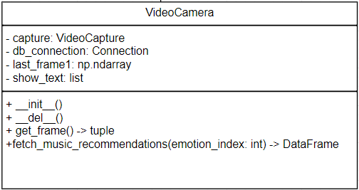
Attributes:
ID | Name | Description | Type
1 | capture | VideoCapture object for  capturing video frames | VideoCapture
2 | db_connection | This attribute handles the  database connection for  fetching music  recommendations. | Connection
3 | last_frame1 | Last captured video frame | np.ndarray
4 | show_text | List to store detected emotionindex | list

Document  Name | Artistverse-SDD V.3.0 | Owner | NS , WS | Page | 29
Document  Type | Software Design  Development | Release Date | 11/10/2024 | Print date | 11/10/2024

Methods:
ID | Name | Description | Parameter | Return Type
1 | init | This method initializesthe video capture and  database connection. | None | None
2 | del | This method releases  the video capture and  closes the database  connection. | None | None
3 | get_frame | This method captures  frames from the  webcam and predicts  the emotion. | None | Tuple (image bytes,DataFrame, emotionstring)
4 | fetch_music_recommendations | This method fetches  music recommendationsbased on the detected  emotion. | emotion_in  dex (int) | DataFrame

Document  Name | Artistverse-SDD V.3.0 | Owner | NS , WS | Page | 30
Document  Type | Software Design  Development | Release Date | 11/10/2024 | Print date | 11/10/2024

3.1.3 Sequence Diagram
ProgressI
3.1.3.1 SD 01 Access Lyric Generation Options
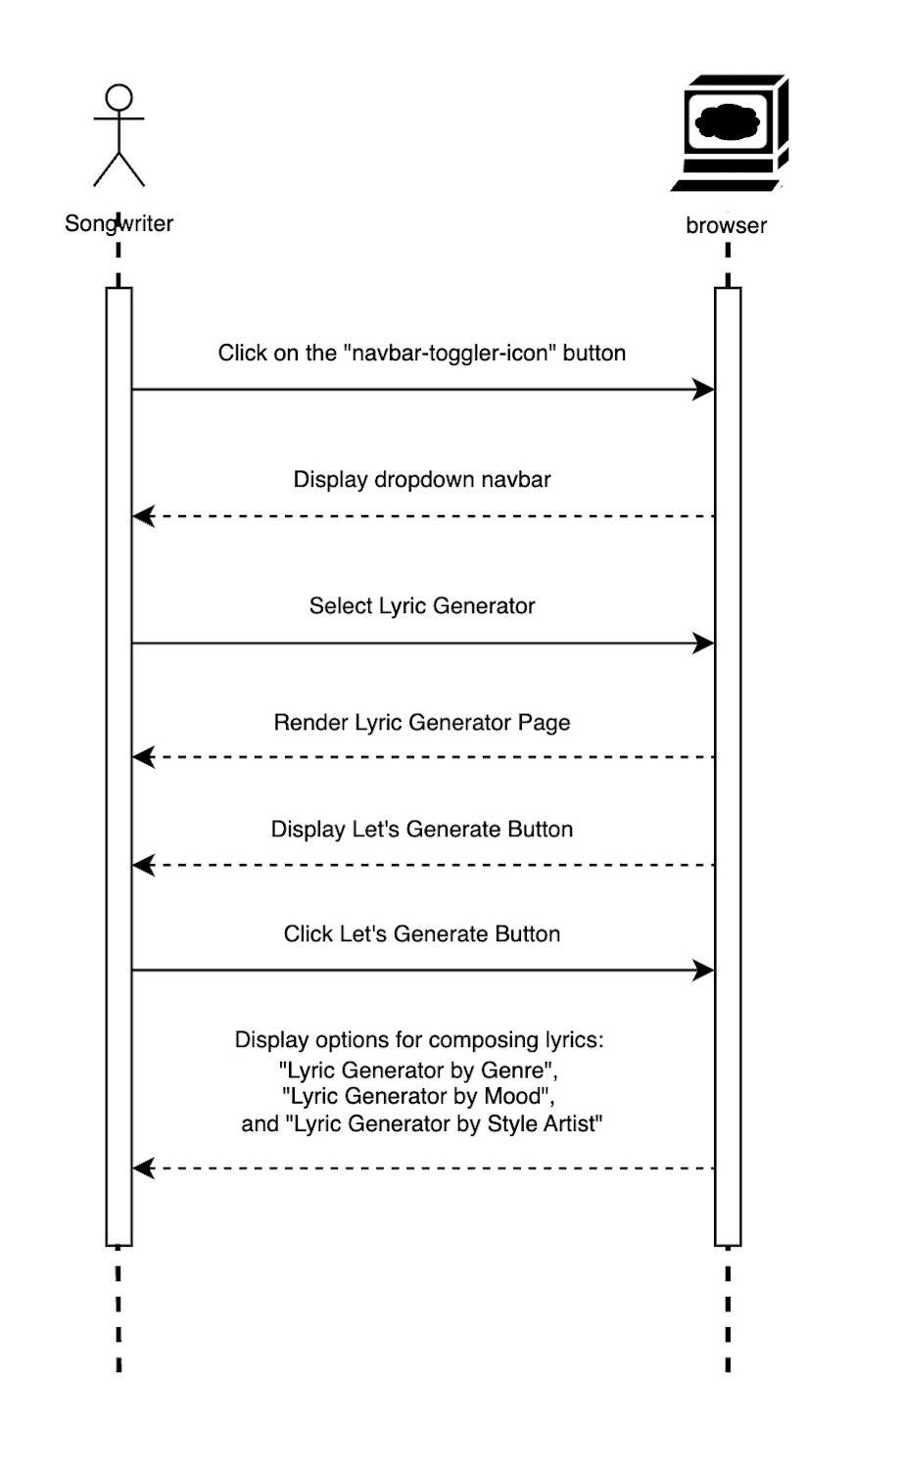
Document  Name | Artistverse-SDD V.3.0 | Owner | NS , WS | Page | 31
Document  Type | Software Design  Development | Release Date | 11/10/2024 | Print date | 11/10/2024

3.1.3.2 SD 02 View Artist Information
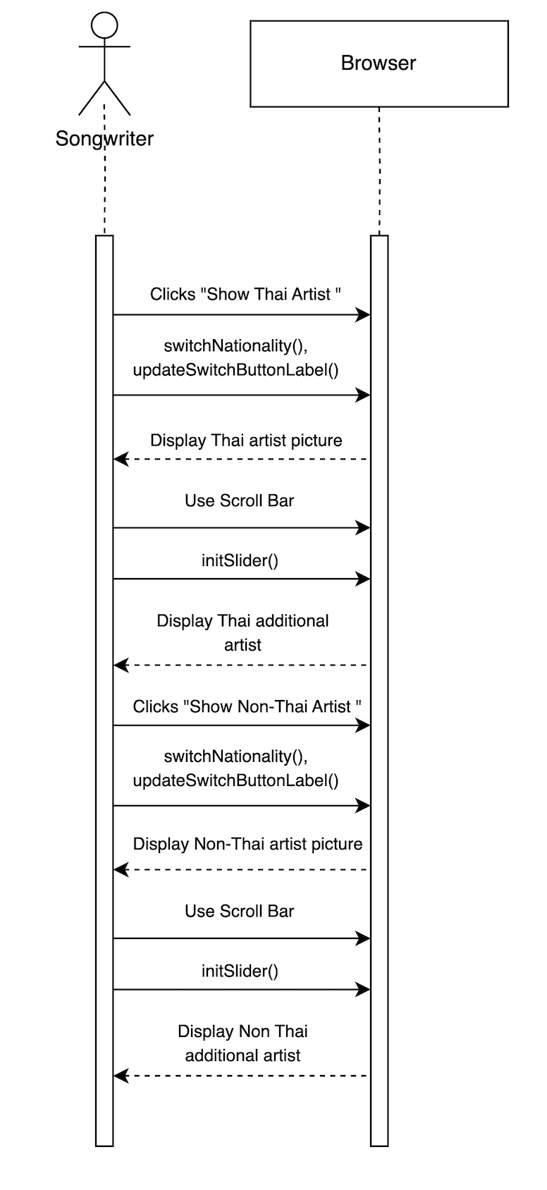
Document  Name | Artistverse-SDD V.3.0 | Owner | NS , WS | Page | 32
Document  Type | Software Design  Development | Release Date | 11/10/2024 | Print date | 11/10/2024

3.1.3.3 SD 03 Compose Lyrics by Genre
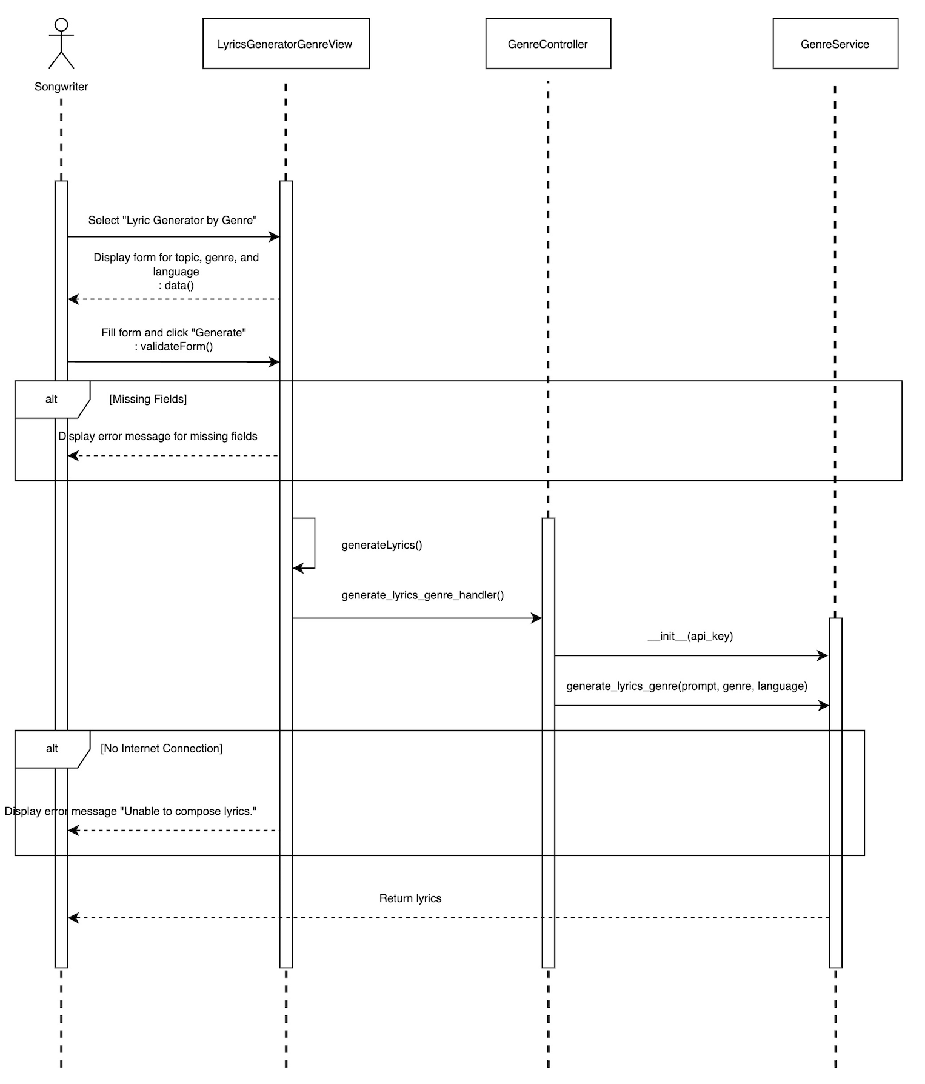
Document  Name | Artistverse-SDD V.3.0 | Owner | NS , WS | Page | 33
Document  Type | Software Design  Development | Release Date | 11/10/2024 | Print date | 11/10/2024

3.1.3.4 SD 04 Compose Lyrics by Mood
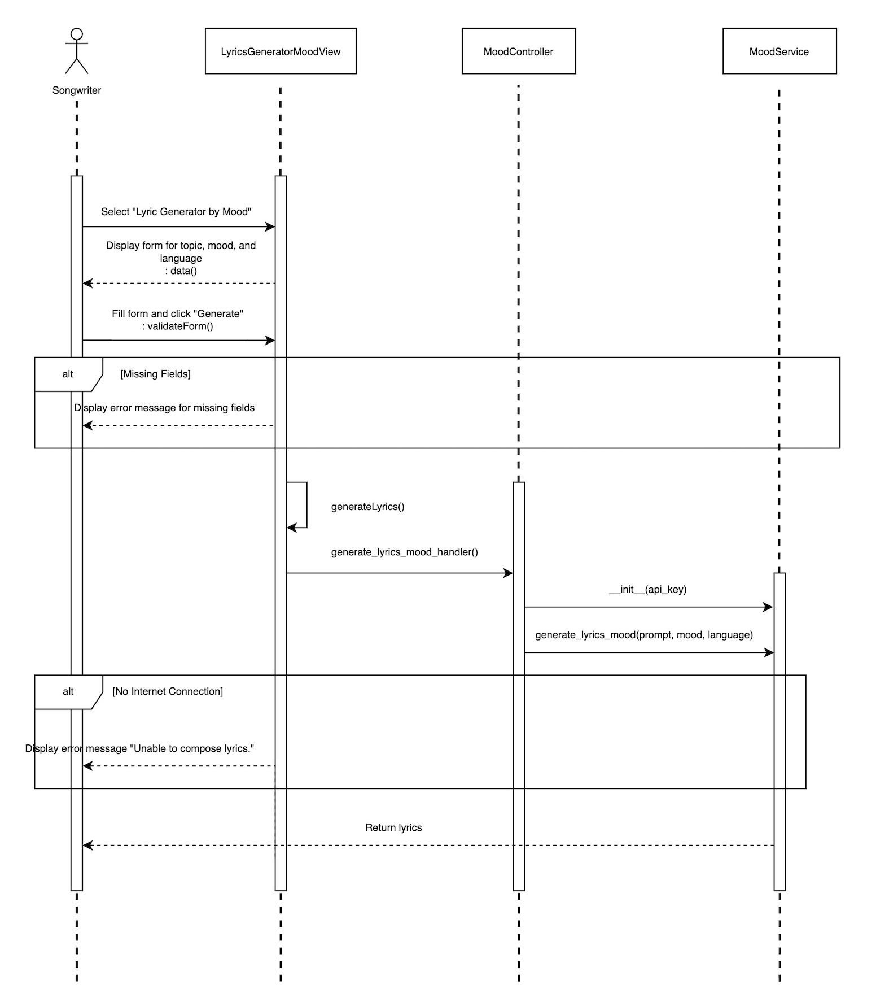
Document  Name | Artistverse-SDD V.3.0 | Owner | NS , WS | Page | 34
Document  Type | Software Design  Development | Release Date | 11/10/2024 | Print date | 11/10/2024

3.1.3.5 SD 05 Compose Lyrics by Style Artist
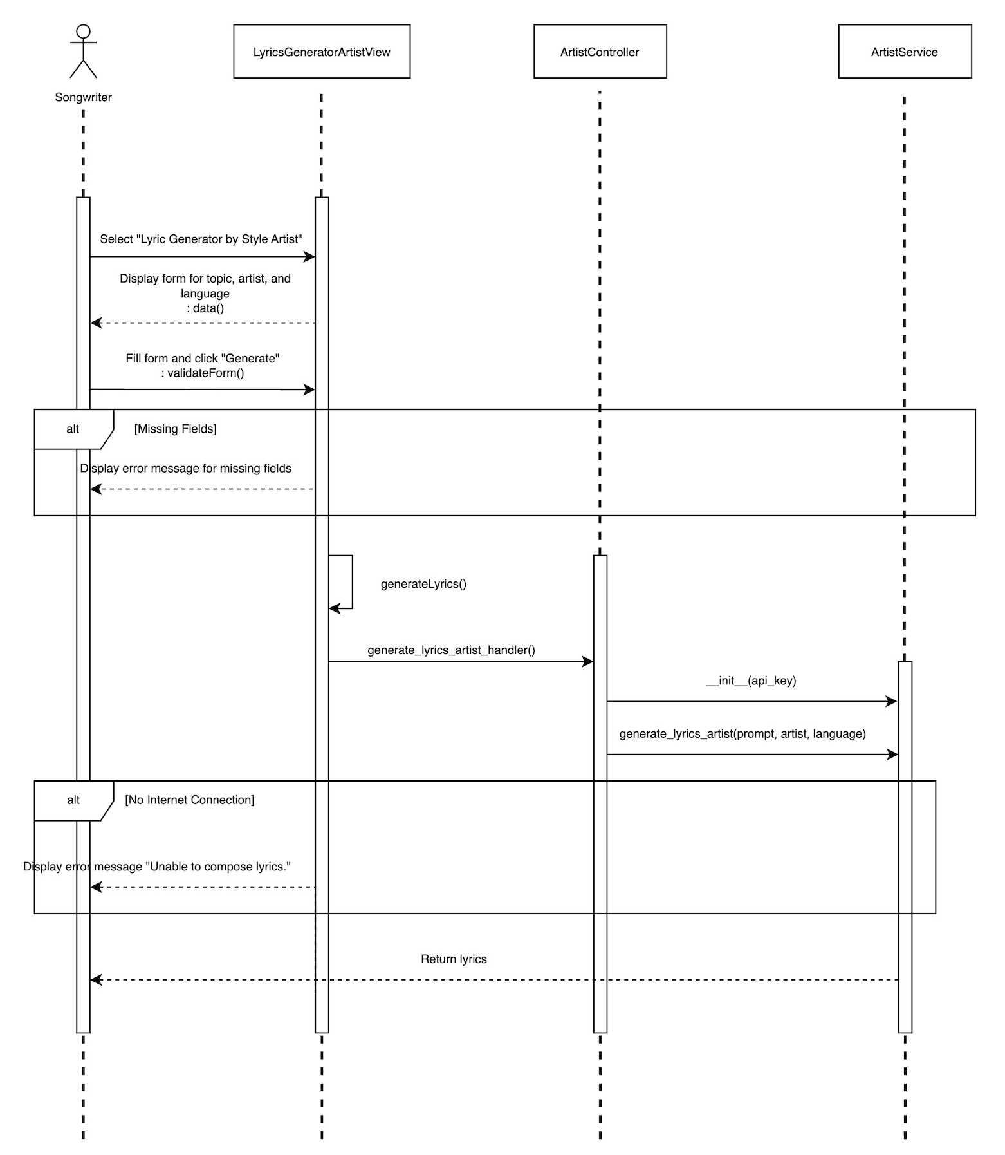
Document  Name | Artistverse-SDD V.3.0 | Owner | NS , WS | Page | 35
Document  Type | Software Design  Development | Release Date | 11/10/2024 | Print date | 11/10/2024

3.1.3.6 SD 06 Save Lyrics
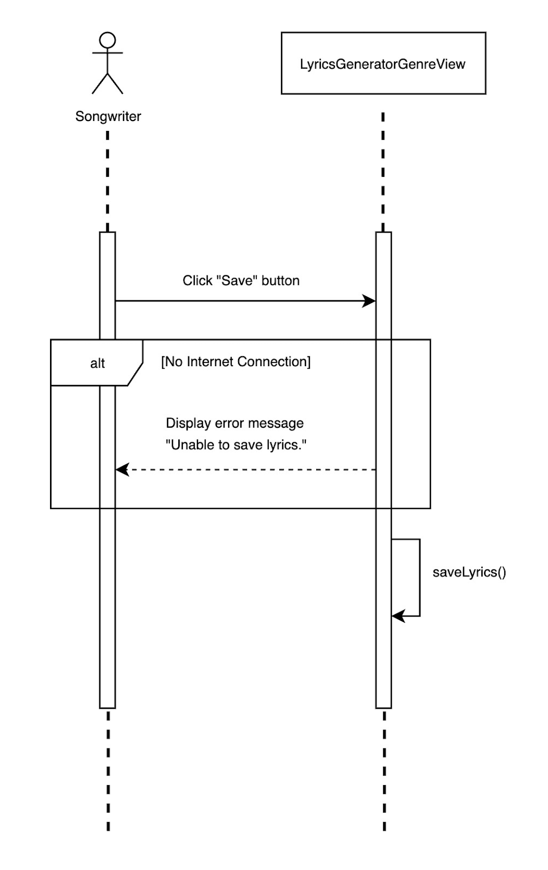
Document  Name | Artistverse-SDD V.3.0 | Owner | NS , WS | Page | 36
Document  Type | Software Design  Development | Release Date | 11/10/2024 | Print date | 11/10/2024

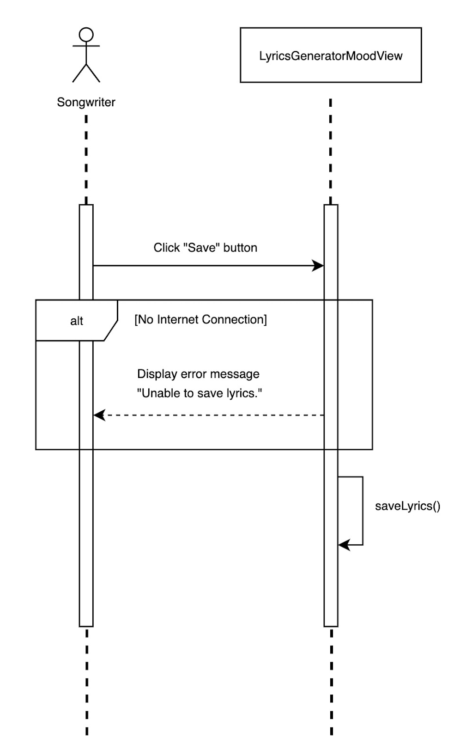
Document  Name | Artistverse-SDD V.3.0 | Owner | NS , WS | Page | 37
Document  Type | Software Design  Development | Release Date | 11/10/2024 | Print date | 11/10/2024

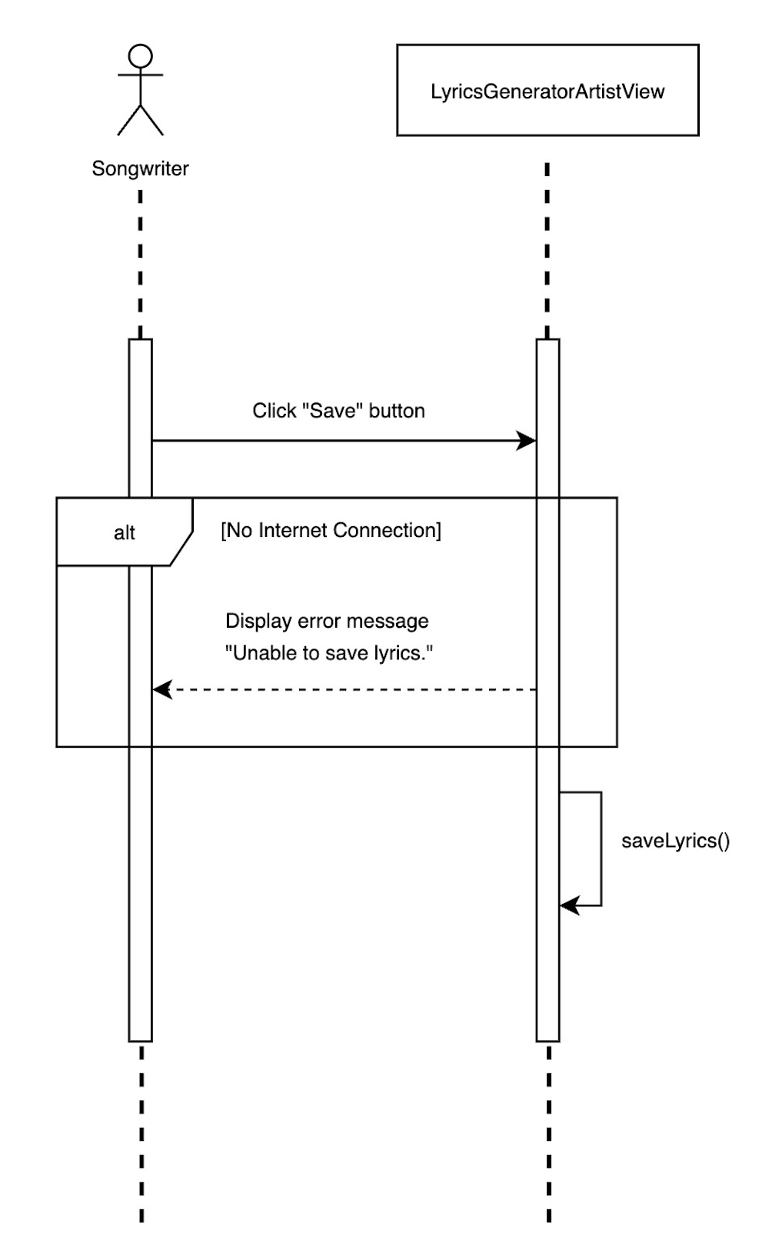
Document  Name | Artistverse-SDD V.3.0 | Owner | NS , WS | Page | 38
Document  Type | Software Design  Development | Release Date | 11/10/2024 | Print date | 11/10/2024

3.1.3.7 SD 07 Capture facial expression and Recommended song
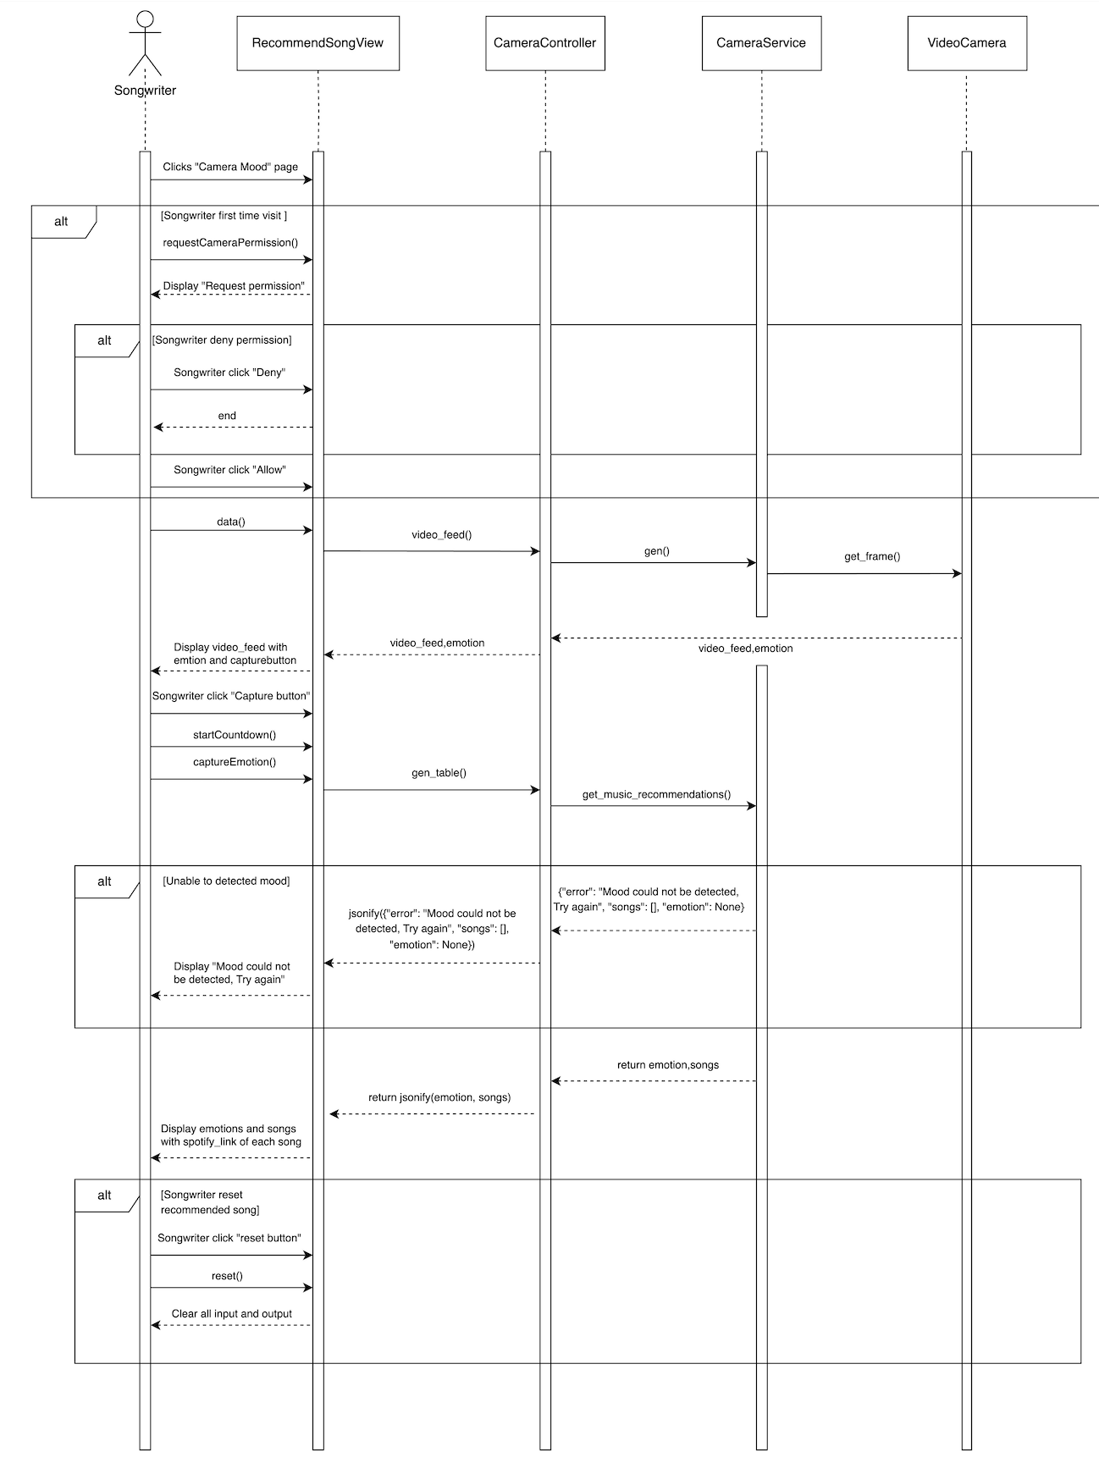
Document  Name | Artistverse-SDD V.3.0 | Owner | NS , WS | Page | 39
Document  Type | Software Design  Development | Release Date | 11/10/2024 | Print date | 11/10/2024

3.1.3.8 SD 08 Select the song from the recommended playlist to redirected to Spotify
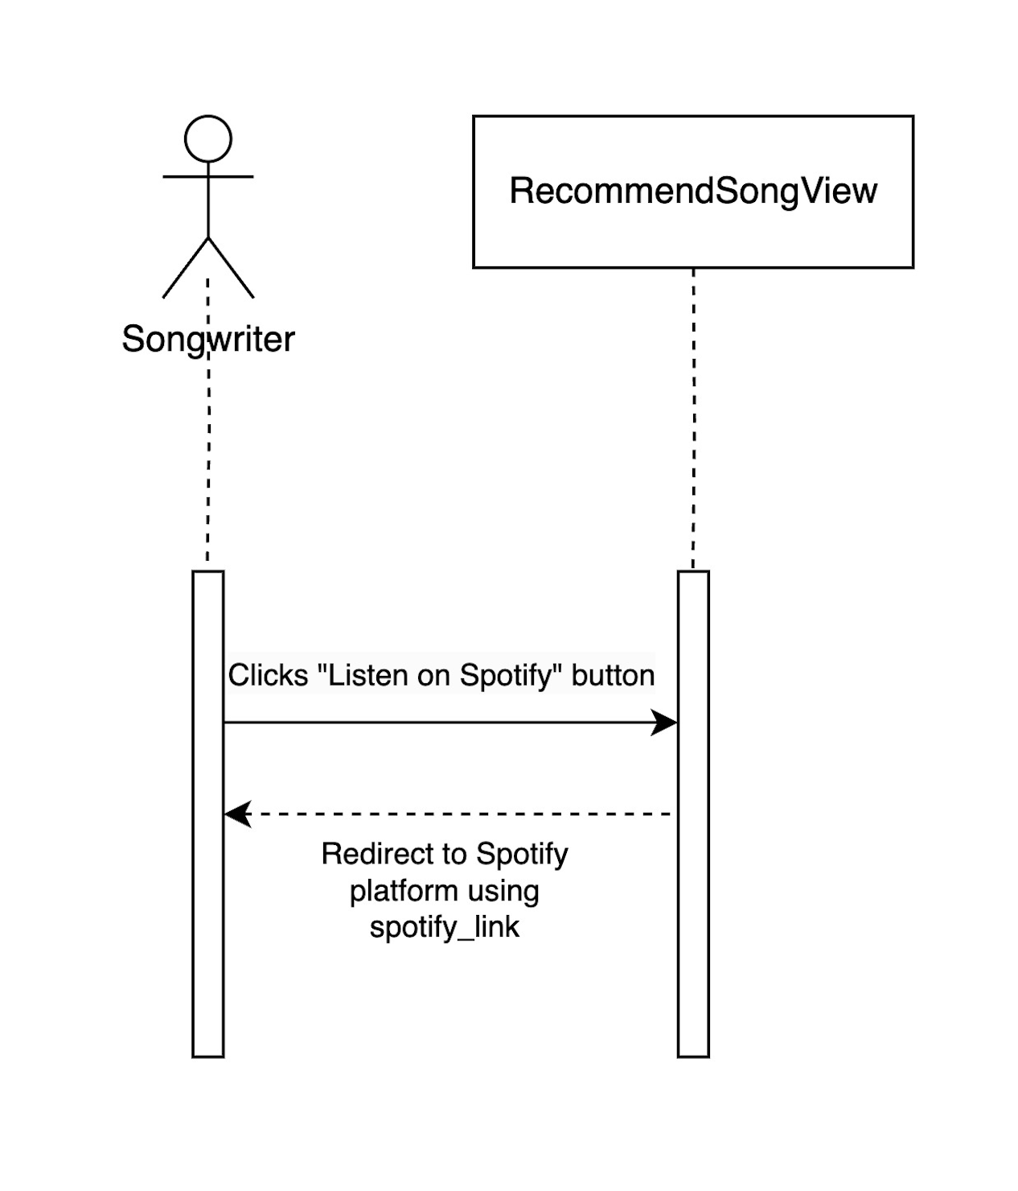
Document  Name | Artistverse-SDD V.3.0 | Owner | NS , WS | Page | 40
Document  Type | Software Design  Development | Release Date | 11/10/2024 | Print date | 11/10/2024

3.2 Progress II
3.2.1 Class Diagram
3.2.1.1 Feature #3: Chord Progression
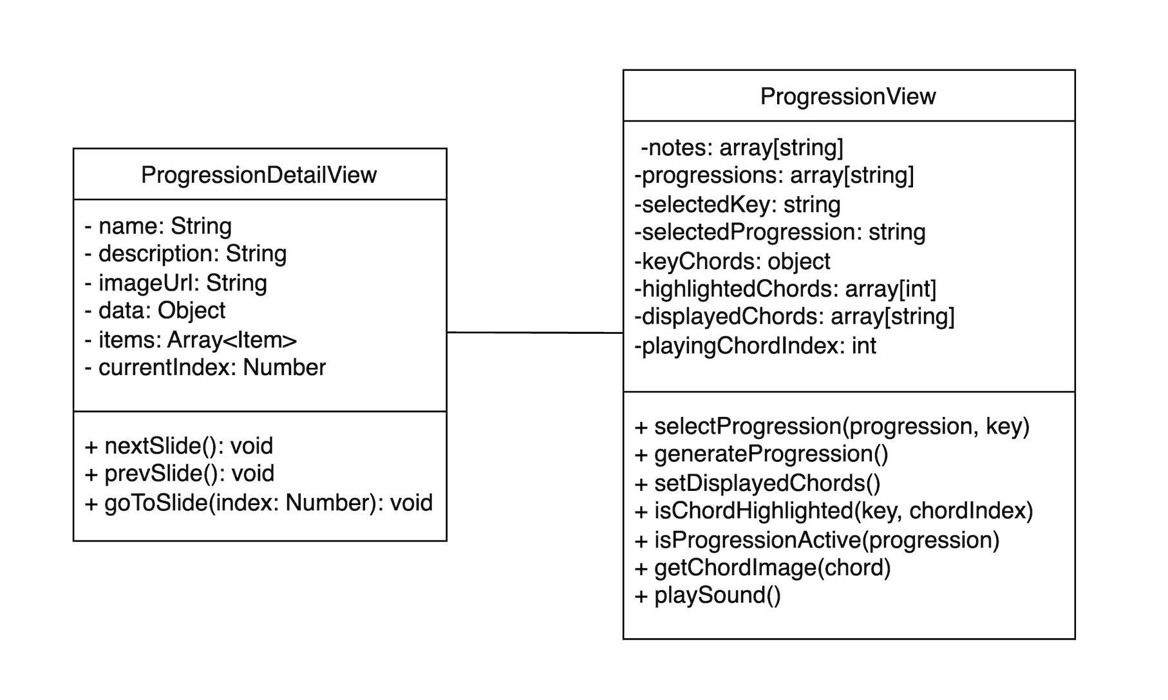
Document  Name | Artistverse-SDD V.3.0 | Owner | NS , WS | Page | 41
Document  Type | Software Design  Development | Release Date | 11/10/2024 | Print date | 11/10/2024

3.2.1.2 Feature #4: Ai Lyrics Analysis
Document  Name | Artistverse-SDD V.3.0 | Owner | NS , WS | Page | 42
Document  Type | Software Design  Development | Release Date | 11/10/2024 | Print date | 11/10/2024
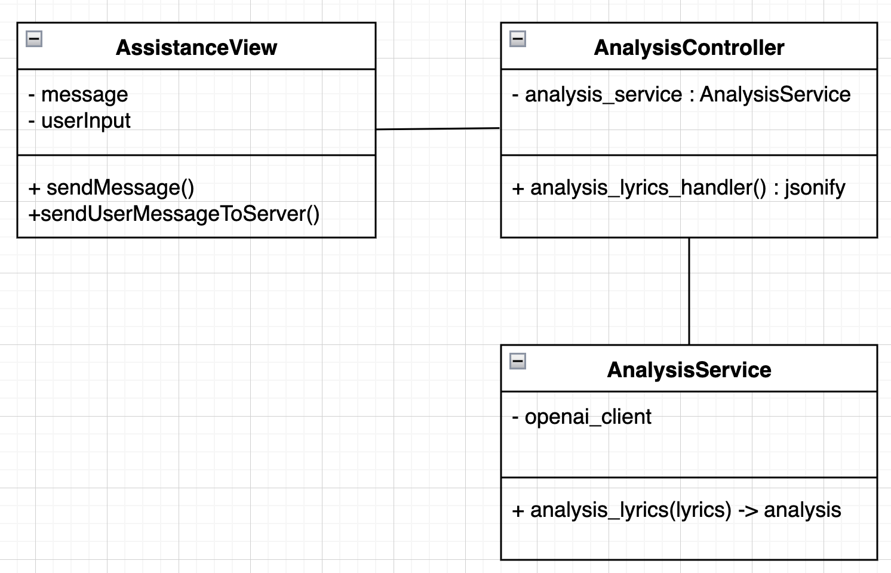
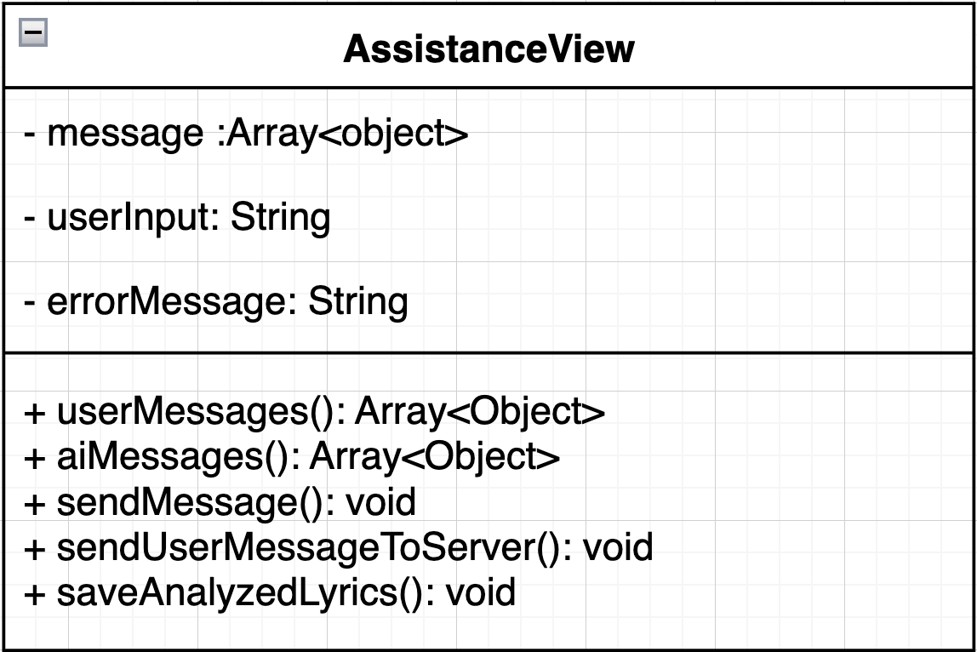

3.2.2 Class Diagram Description
3.2.2.1 Views
3.2.2.1.1 Views: ProgressionDetailView
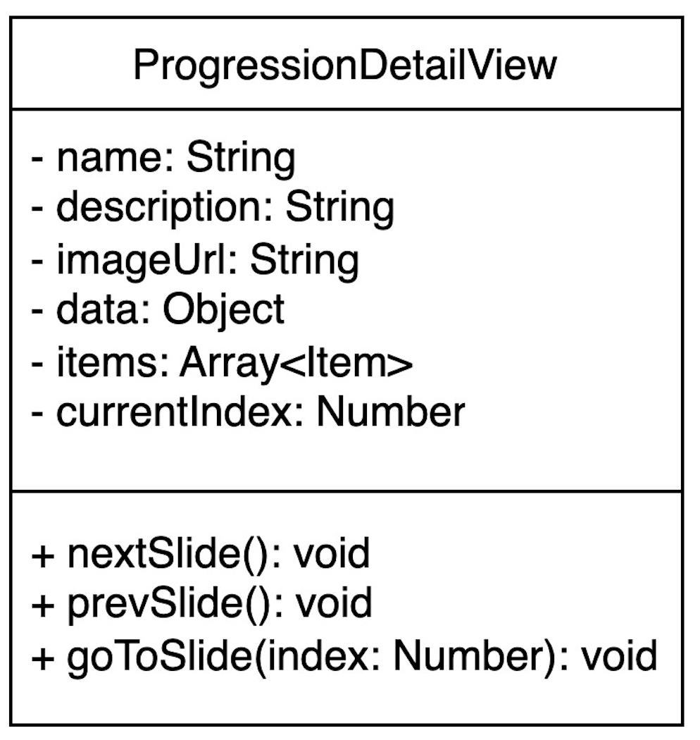
Attributes:
ID | Name | Description | Type
1 | name | This attribute stores the nameof the progression or view. | String
2 | description | This attribute holds a brief  description or explanation of  the progression. | String
3 | imageUrl | This attribute contains the URLof an image associated with theprogression. | String
4 | data | This attribute stores additionalinformation or metadata relatedto the progression. | Object
5 | items | This attribute is an array that | Array<Item>

Document  Name | Artistverse-SDD V.3.0 | Owner | NS , WS | Page | 43
Document  Type | Software Design  Development | Release Date | 11/10/2024 | Print date | 11/10/2024

contains items related to the
progression, such as steps or
details.
6 | currentIndex | This attribute tracks the currentindex of the displayed item orslide in the progression. | Name
Methods:
ID | Name | Description | Parameter | Return Type
1 | nextSlide() | This method advances  to the next slide or itemin the progression view. | None | void
2 | prevSlide() | This method moves  back to the previous  slide or item. | None | void
3 | goToSlide(index:  Number) | This method navigates  directly to a specific  slide or item based on  the provided index. | index:  Number | void

Document  Name | Artistverse-SDD V.3.0 | Owner | NS , WS | Page | 44
Document  Type | Software Design  Development | Release Date | 11/10/2024 | Print date | 11/10/2024

3.2.2.1.2 Views: ProgressionView
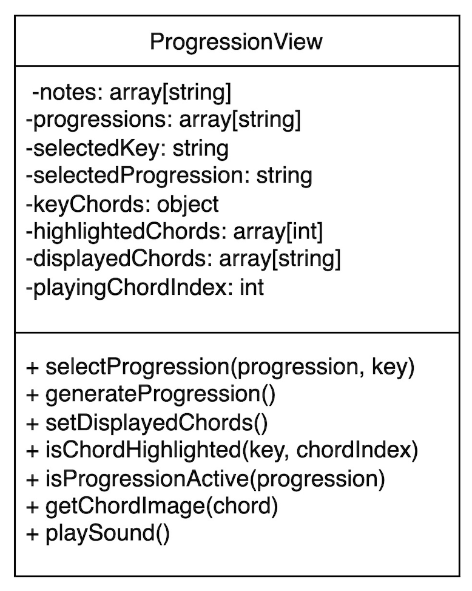
Attributes:
ID | Name | Description | Type
1 | notes | This attribute is an array that  stores musical notes relevant tothe progression. | String
2 | progressions | This attribute is an array that  stores different chord  progressions. | Array[String]
3 | selectedKey | This attribute stores the  currently selected musical key. | String
4 | selectedProgression | This attribute stores the  currently selected chord  progression. | String
5 | keyChords | This attribute stores an objectthat maps each key to its  corresponding chords. | object

Document  Name | Artistverse-SDD V.3.0 | Owner | NS , WS | Page | 45
Document  Type | Software Design  Development | Release Date | 11/10/2024 | Print date | 11/10/2024

6 | highlightedChords | This attribute stores an array ofindices indicating which chordsare highlighted in the current  progression. | Array[int]
7 | displayedChords | This attribute is an array that  stores the chords currently  displayed based on the selectedkey and progression. | Array[String]
8 | playingChordIndex | This attribute stores the indexof the chord that is currently  being played. | int
Methods:
ID | Name | Description | Parameter | Return Type
1 | selectProgression  (progression, key) | This method selects a  specific chord  progression and musicalkey. | progression:String  key: String | void
2 | generateProgression() | This method generates  the chord progression  based on the selected  key. | None | void
3 | setDisplayedChords() | This method updates thedisplayedChords arraybased on the selected  progression and key. | None | void
4 | isChordHighlighted(key, chordIndex) | This method checks if aspecific chord is  highlighted. | key: String  chordIndex:Number | Boolean
5 | isProgressionActive(progression) | This method checks if aspecific progression is  currently active. | progression:String | Boolean

Document  Name | Artistverse-SDD V.3.0 | Owner | NS , WS | Page | 46
Document  Type | Software Design  Development | Release Date | 11/10/2024 | Print date | 11/10/2024

6 | getChordImage(chord) | This method retrieves  the image associated  with a specific chord. | chord:  String | String (The URL orpath to the image)
7 | playSound() | This method plays the  sound of the currently  selected or highlightedchord. | None | void

Document  Name | Artistverse-SDD V.3.0 | Owner | NS , WS | Page | 47
Document  Type | Software Design  Development | Release Date | 11/10/2024 | Print date | 11/10/2024

3.2.2.1.1 Views: AssistanceView

Attributes:
ID | Name | Description | Type
1 | messages | Stores a list of messages, where  each message has an id (number), arole (string, either "user" or "ai"),and content (string) representingthe text of the message. | Array<{ id: number,role: string, content:string }>
2 | userInput | Holds the current input text fromthe user, which is bound to the  input field in the template. | String
3 | errorMessage | Holds any error messages to be  displayed if there are issues withuser input or network connectivity. | String

Document  Name | Artistverse-SDD V.3.0 | Owner | NS , WS | Page | 48
Document  Type | Software Design  Development | Release Date | 11/10/2024 | Print date | 11/10/2024

Methods:
ID | Name | Description | Parameter | Return Type
1 | sendMessage() | Checks if the userInputis not empty, pushes  the message to the  messages array, and  calls  sendUserMessageToServer(). Then it clears  the userInput. | None | void
2 | sendUserMessageToServer() | Sends the userInput tothe server via a POSTrequest and updates themessages array with  the AI's response. | None | void
3 | saveAnalyzedLyrics() | Checks if there is an  internet connection  and whether any  analyzed lyrics are  present. If checks arepassed, it concatenatesall AI messages and  initiates a download ofthe analyzed lyrics as atext file. Handles  errors or issues in theprocess. | None | void
4 | userMessages() | Filters and returns  messages from the  messages array that  have a role of "user". | None | Array<{ id:  number, role:  string, content:  string }>
5 | aiMessage() | Filters and returns  messages from the  messages array that  have a role of "ai". | None | Array<{ id:  number, role:  string, content:  string }>

Document  Name | Artistverse-SDD V.3.0 | Owner | NS , WS | Page | 49
Document  Type | Software Design  Development | Release Date | 11/10/2024 | Print date | 11/10/2024

3.2.2.2 Controller
3.2.2.2.1 Controller: AnalysisController
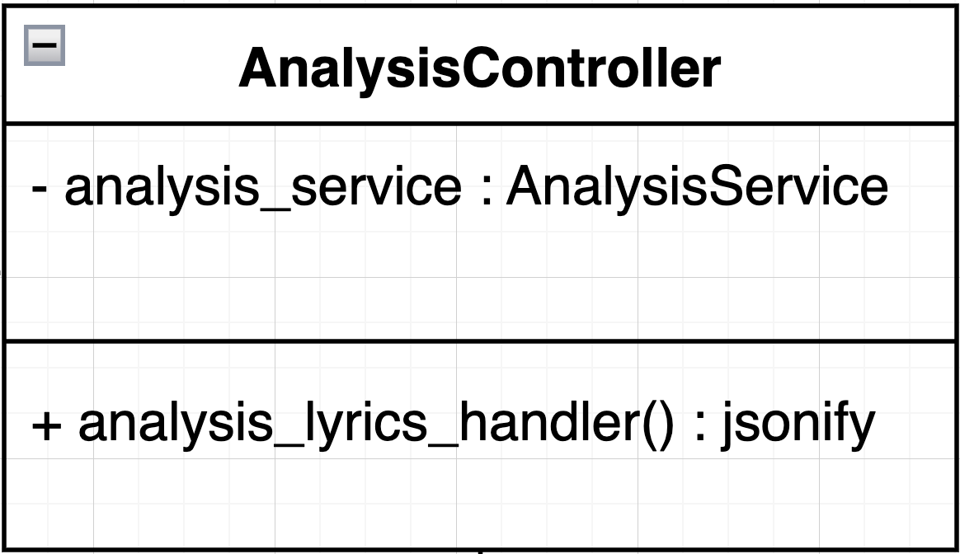
Attributes:
ID | Name | Description | Type
1 | analysis_service | An instance of the  AnalysisService class used toperform the lyrics analysis. | AnalysisService
Methods:
ID | Name | Description | Parameter | Return Type
1 | init(api_key: str) | Initializes the controllerwith the necessary APIkey to access the genreservice | api_key: str | Response
2 | analysis_lyrics_handler() | Receives lyrics from a  JSON request, passes  them to the  AnalysisService for  processing, and returnsa JSON response with  the analysis result. | None | Response

Document  Name | Artistverse-SDD V.3.0 | Owner | NS , WS | Page | 50
Document  Type | Software Design  Development | Release Date | 11/10/2024 | Print date | 11/10/2024

3.2.2.3 Service
3.2.2.3.1 Service: AnalysisService
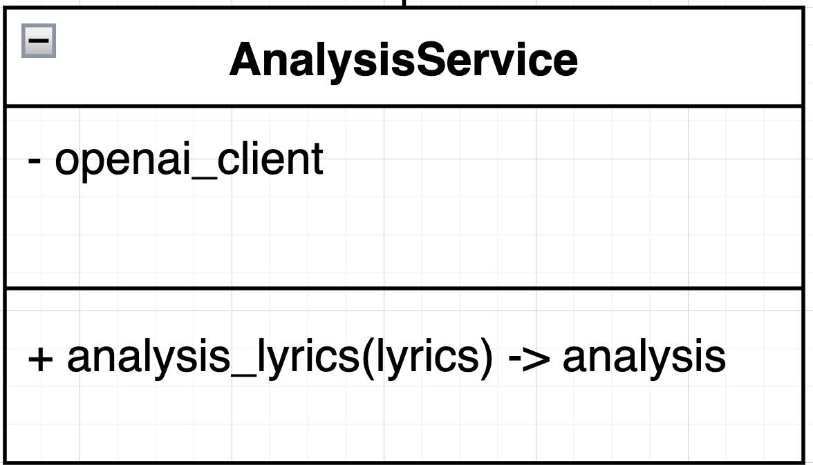
Attributes:
ID | Name | Description | Type
1 | openai_client | An instance of the OpenAI APIclient used to communicate  with the OpenAI API. | OpenAI Client
Methods:
ID | Name | Description | Parameter | Return Type
1 | analysis_lyrics(lyrics) | Takes lyrics as a  string, sends them tothe OpenAI API, andreturns a string  containing the  AI-generated  analysis of the lyrics. | lyrics: str | String

Document  Name | Artistverse-SDD V.3.0 | Owner | NS , WS | Page | 51
Document  Type | Software Design  Development | Release Date | 11/10/2024 | Print date | 11/10/2024

3.2.3 Sequence Diagram
3.2.3.9 SD 09 Access and View Chord Progression Information
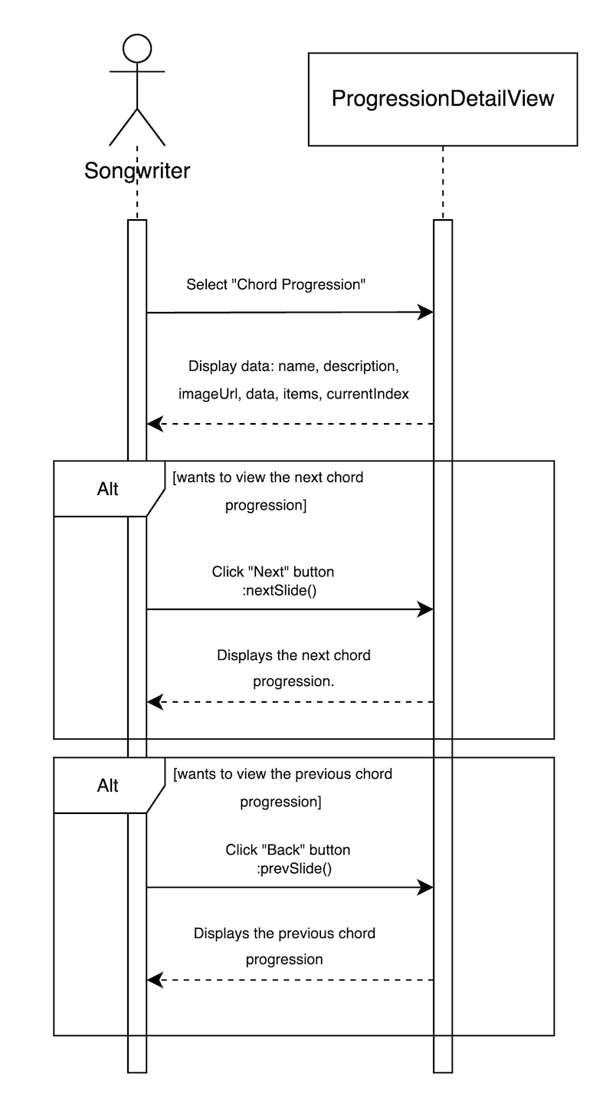
Document  Name | Artistverse-SDD V.3.0 | Owner | NS , WS | Page | 52
Document  Type | Software Design  Development | Release Date | 11/10/2024 | Print date | 11/10/2024

3.2.3.10 SD 10 Chord Progression Chart Interaction
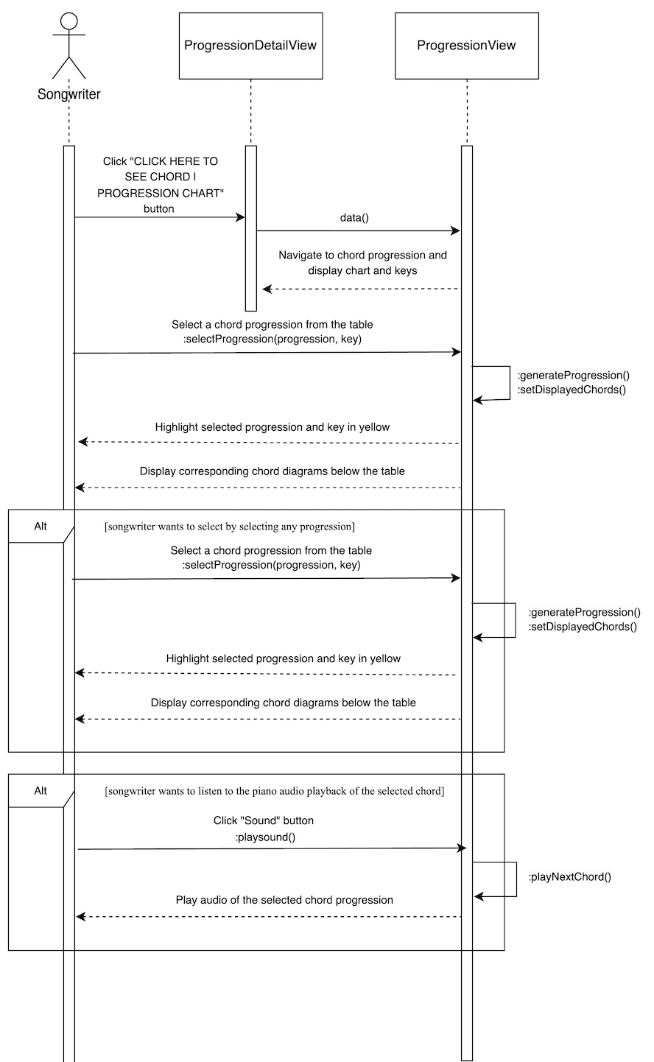
Document  Name | Artistverse-SDD V.3.0 | Owner | NS , WS | Page | 53
Document  Type | Software Design  Development | Release Date | 11/10/2024 | Print date | 11/10/2024

3.2.3.11 SD 11 Input Lyrics and View Musical Analysis
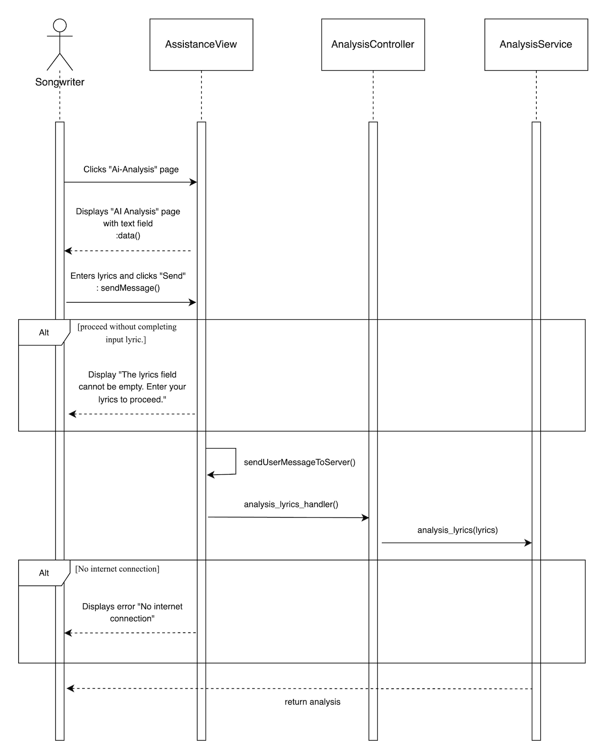
Document  Name | Artistverse-SDD V.3.0 | Owner | NS , WS | Page | 54
Document  Type | Software Design  Development | Release Date | 11/10/2024 | Print date | 11/10/2024

3.2.3.12 SD 12 Save Analyzed Lyrics
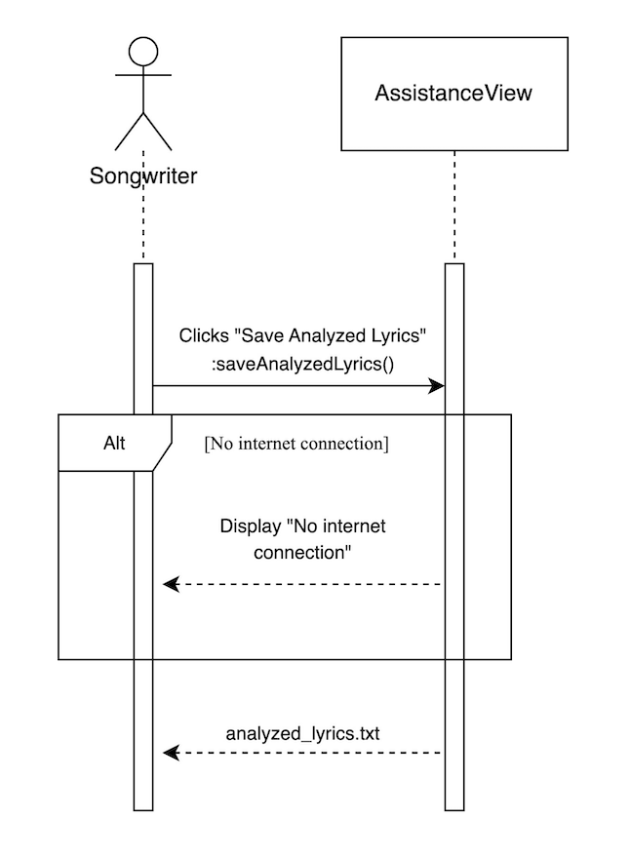
Document  Name | Artistverse-SDD V.3.0 | Owner | NS , WS | Page | 55
Document  Type | Software Design  Development | Release Date | 11/10/2024 | Print date | 11/10/2024

Chapter 4 User Interface Design
4.1 Progress I
4.1.1 Web Application UI
UI-01 Home page
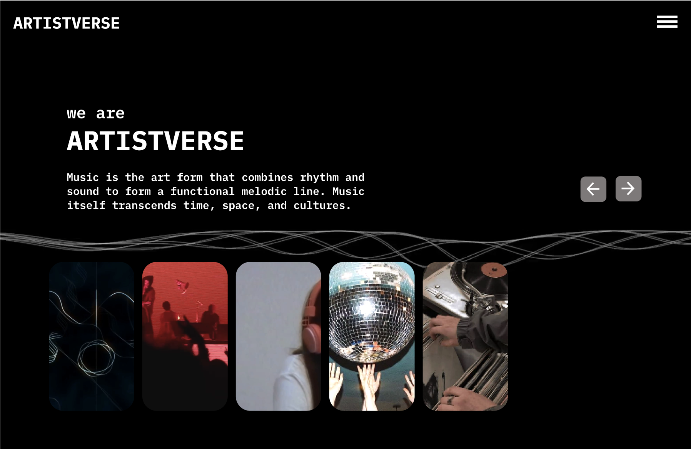
UI-02 Home page with "navbar-toggler-icon" button
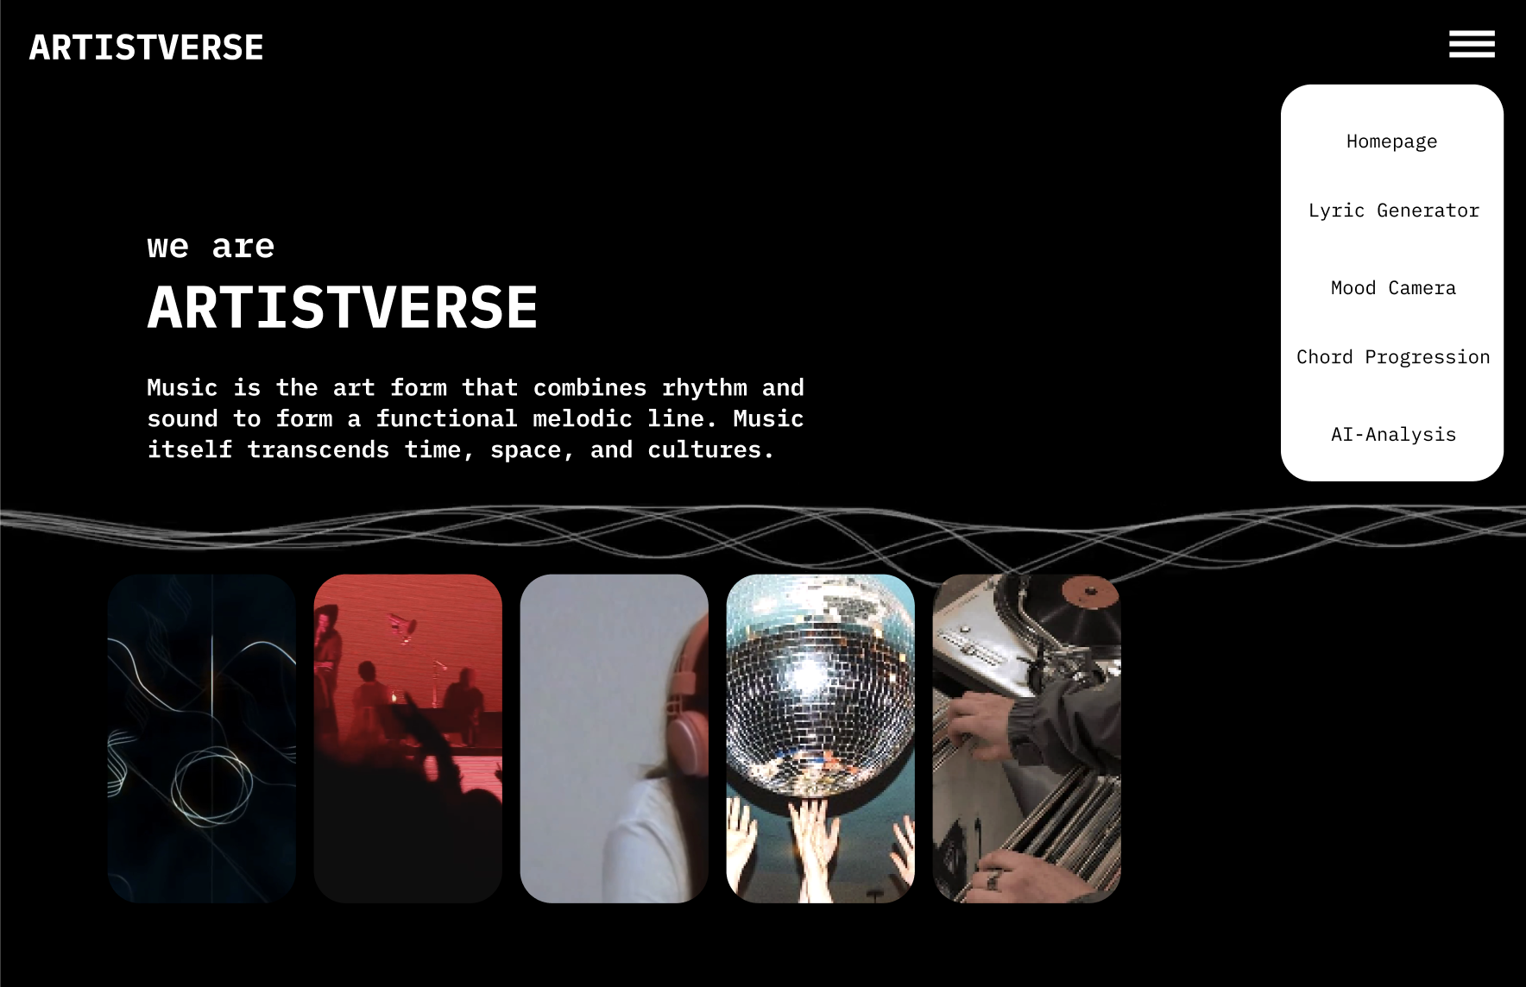
Document  Name | Artistverse-SDD V.3.0 | Owner | NS , WS | Page | 56
Document  Type | Software Design  Development | Release Date | 11/10/2024 | Print date | 11/10/2024

UI-03 Lyric Generator page with "Let’s generate" button that can
redirect the Songwriter to the lyrics generator by Genre page and
information about including the Non-thai artist.
x
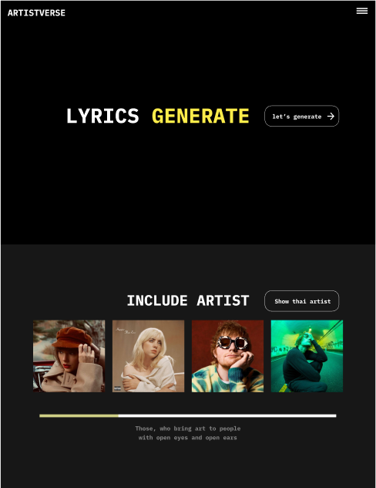
Document  Name | Artistverse-SDD V.3.0 | Owner | NS , WS | Page | 57
Document  Type | Software Design  Development | Release Date | 11/10/2024 | Print date | 11/10/2024

UI-03-1 Lyric Generator page with "Let’s generate" button that can
redirect the Songwriter to the lyrics generator by Genre page and
information about including the Thai artist.
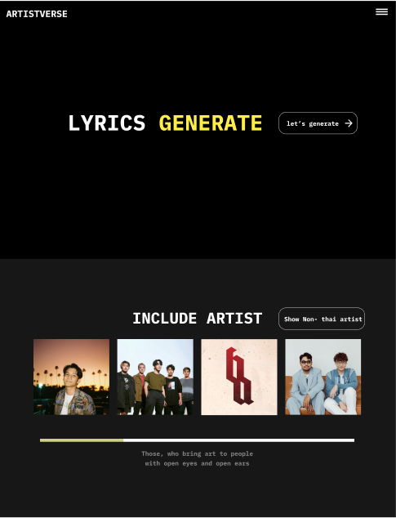
Document  Name | Artistverse-SDD V.3.0 | Owner | NS , WS | Page | 58
Document  Type | Software Design  Development | Release Date | 11/10/2024 | Print date | 11/10/2024

UI-04 Lyric Generator by Genre Page
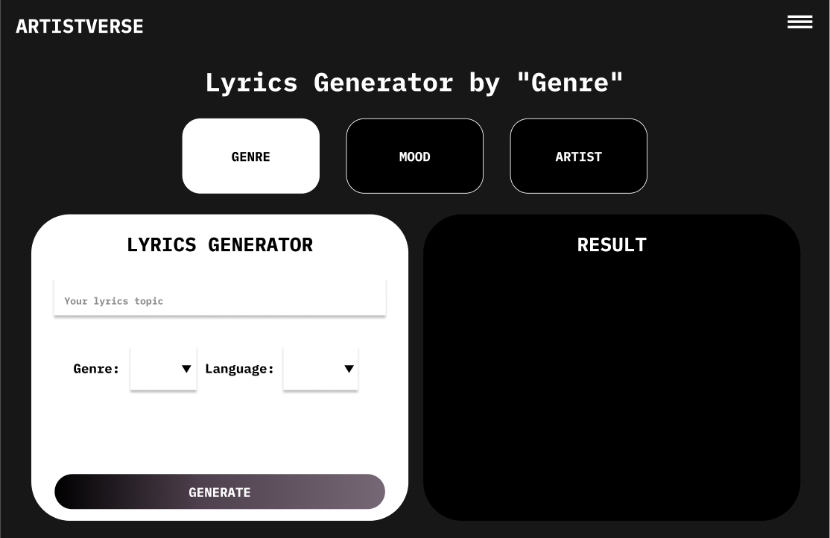
UI-04-1 With invalid input
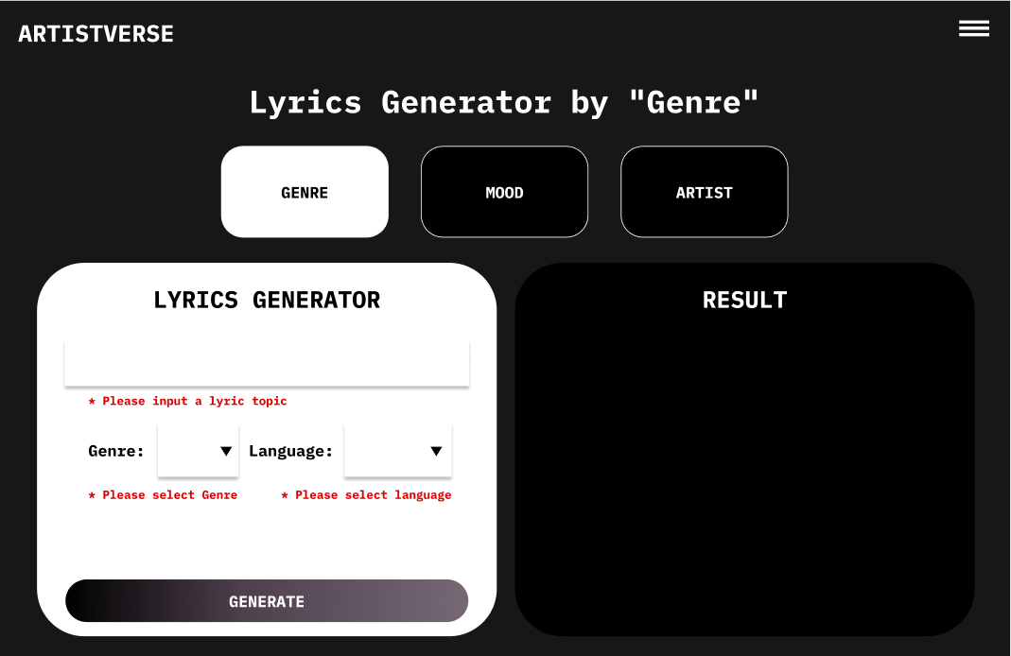
Document  Name | Artistverse-SDD V.3.0 | Owner | NS , WS | Page | 59
Document  Type | Software Design  Development | Release Date | 11/10/2024 | Print date | 11/10/2024

UI-04-2 With input information
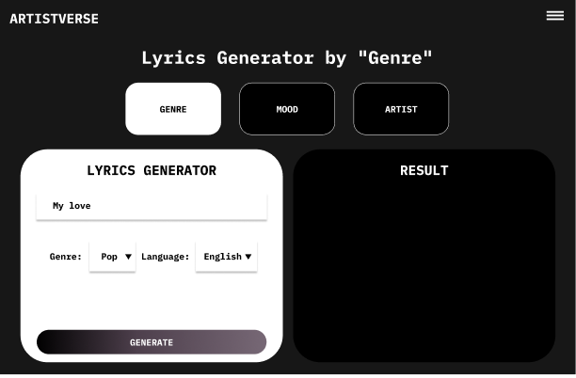
UI-04-3 With display the created lyrics
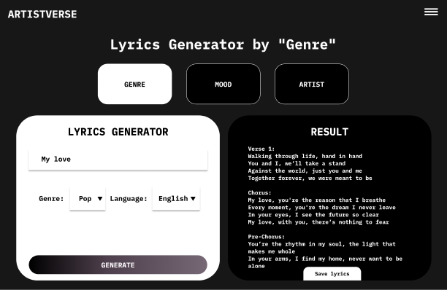
Document  Name | Artistverse-SDD V.3.0 | Owner | NS , WS | Page | 60
Document  Type | Software Design  Development | Release Date | 11/10/2024 | Print date | 11/10/2024

UI-04-4 With causing by no internet connection
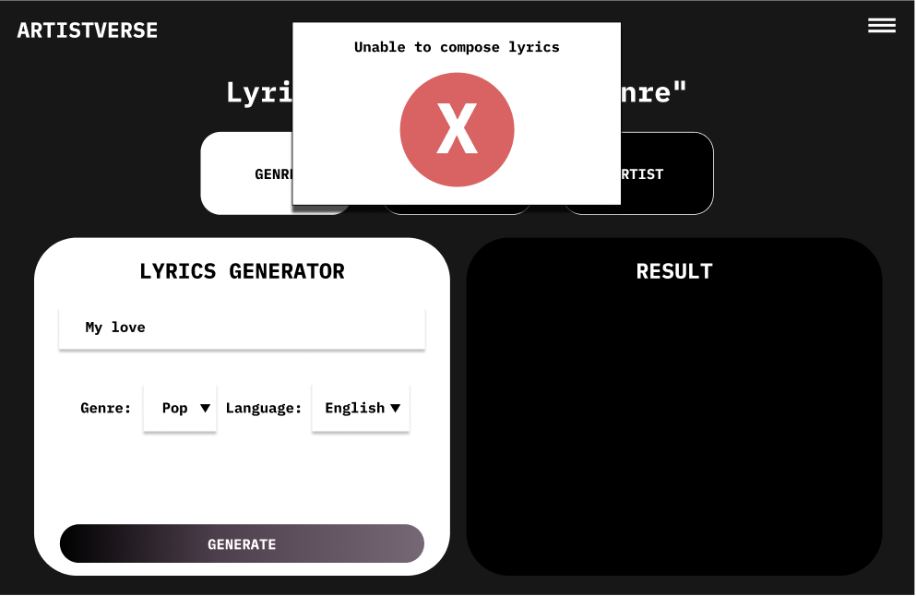
UI-05 Lyric Generator by Mood page
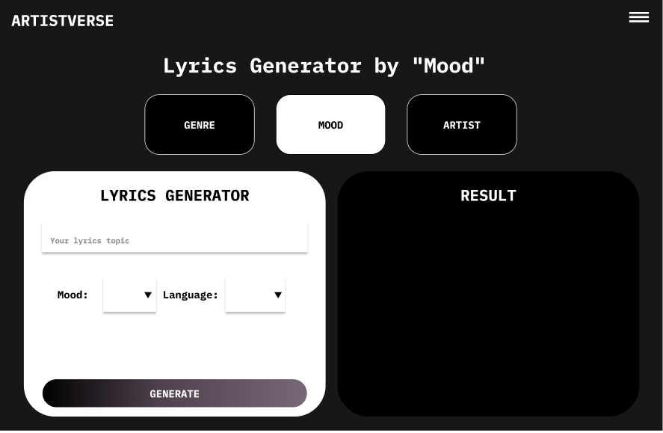
Document  Name | Artistverse-SDD V.3.0 | Owner | NS , WS | Page | 61
Document  Type | Software Design  Development | Release Date | 11/10/2024 | Print date | 11/10/2024

UI-05-1 With input information
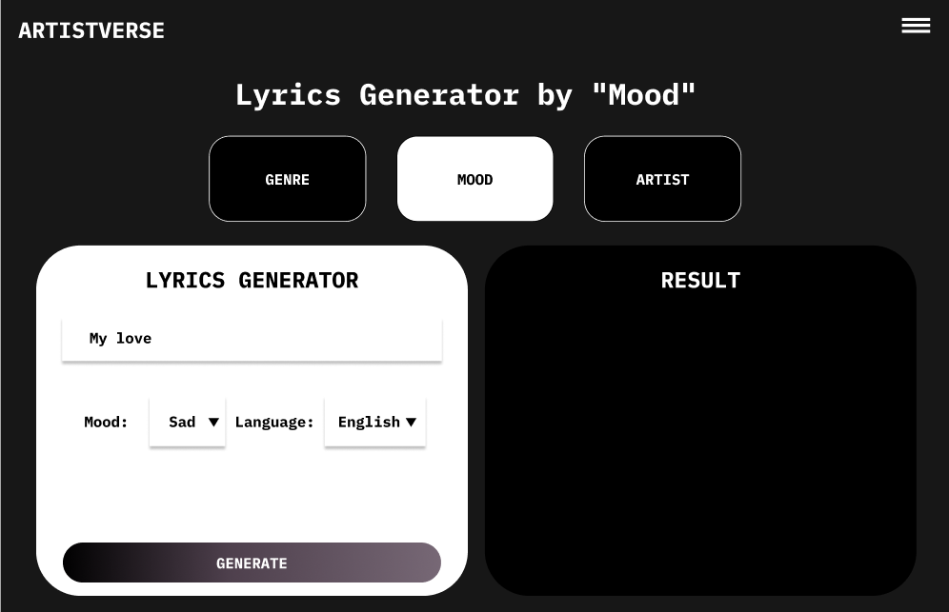
UI-05-2 With invalid input
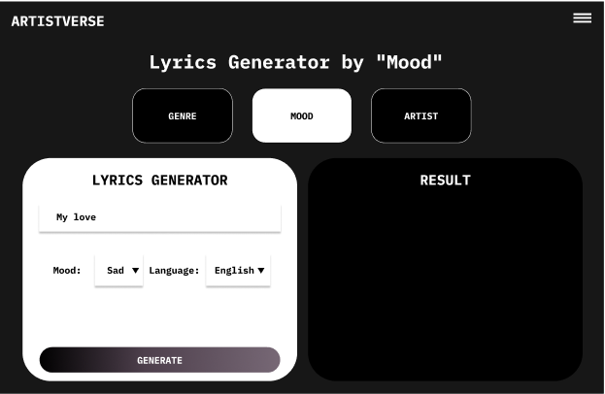
Document  Name | Artistverse-SDD V.3.0 | Owner | NS , WS | Page | 62
Document  Type | Software Design  Development | Release Date | 11/10/2024 | Print date | 11/10/2024

UI-05-3 With causing by no internet connection
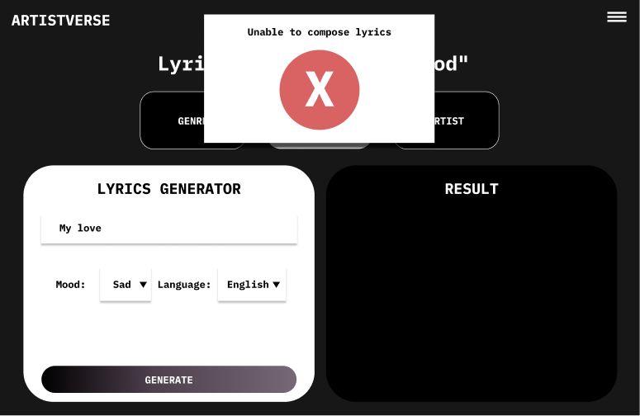
UI-05-4 With display the created lyrics
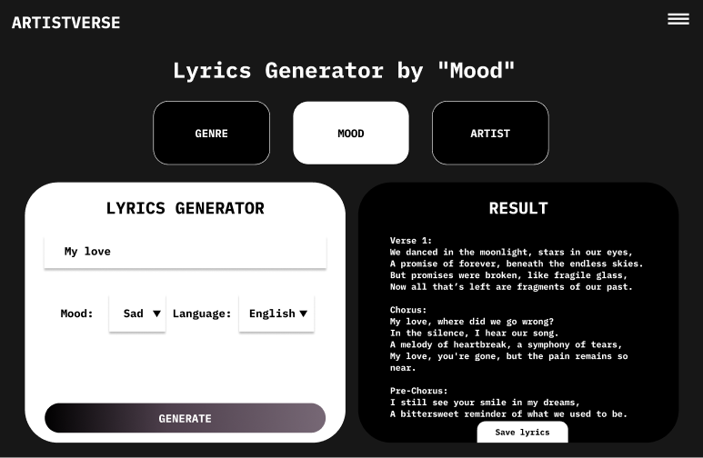
Document  Name | Artistverse-SDD V.3.0 | Owner | NS , WS | Page | 63
Document  Type | Software Design  Development | Release Date | 11/10/2024 | Print date | 11/10/2024

UI-06 Lyric Generator by Style Artist Page
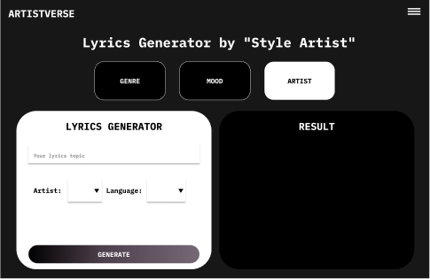
UI-06-1 With invalid input
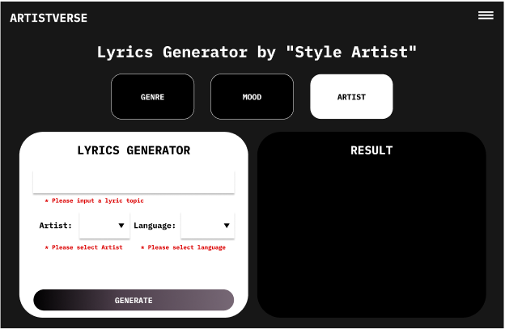
Document  Name | Artistverse-SDD V.3.0 | Owner | NS , WS | Page | 64
Document  Type | Software Design  Development | Release Date | 11/10/2024 | Print date | 11/10/2024

UI-06-2 With input information
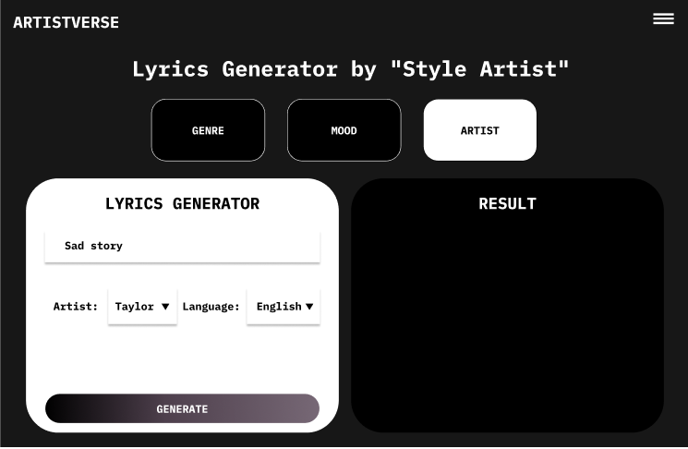
UI–06-3 With causing by no internet connection
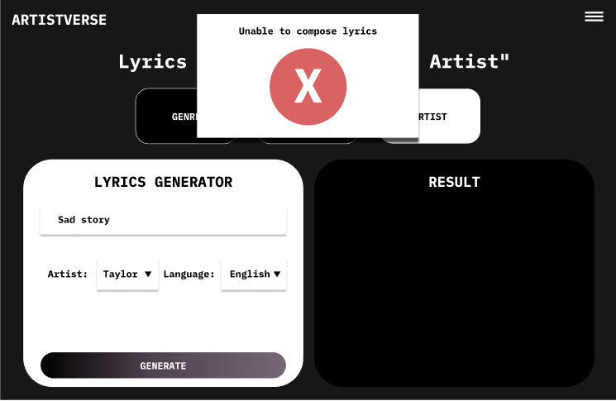
Document  Name | Artistverse-SDD V.3.0 | Owner | NS , WS | Page | 65
Document  Type | Software Design  Development | Release Date | 11/10/2024 | Print date | 11/10/2024

UI-06-4 With display the created lyrics
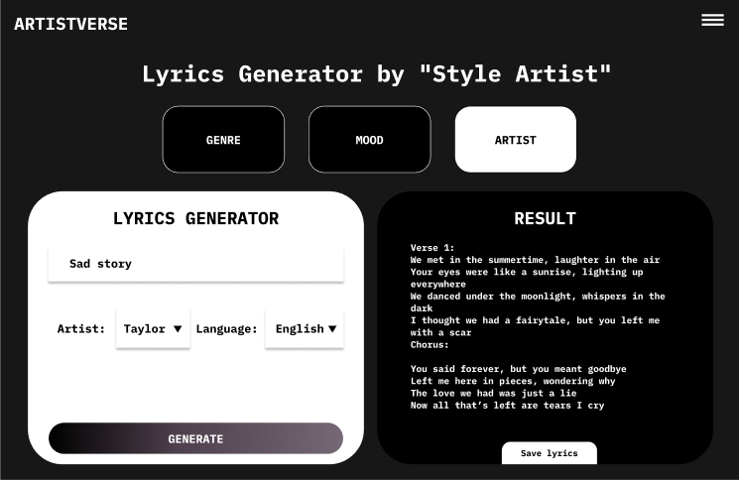
UI-07 Lyric Generator page with save lyrics
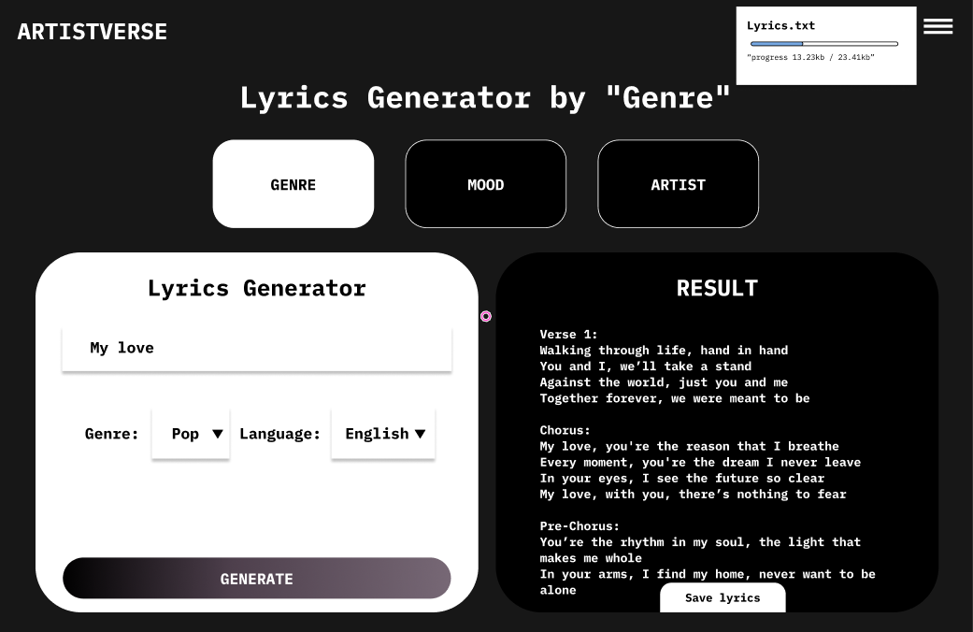
Document  Name | Artistverse-SDD V.3.0 | Owner | NS , WS | Page | 66
Document  Type | Software Design  Development | Release Date | 11/10/2024 | Print date | 11/10/2024

UI-07-1 With Unable to save lyrics causing by no internet connection
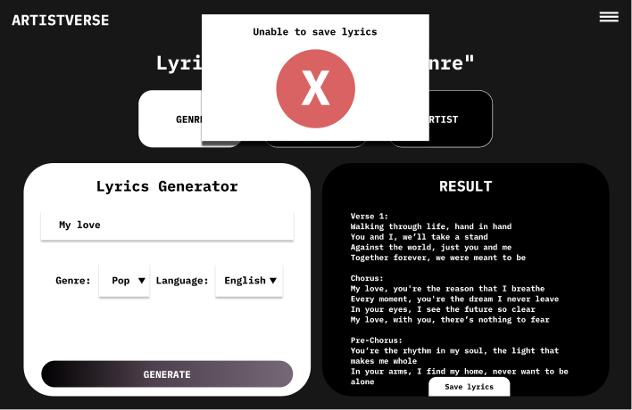
UI-08 Camera mood page
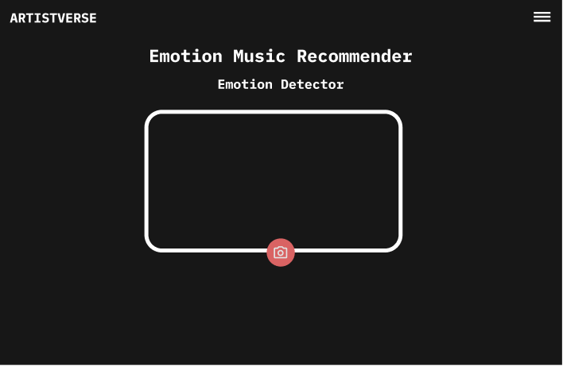
Document  Name | Artistverse-SDD V.3.0 | Owner | NS , WS | Page | 67
Document  Type | Software Design  Development | Release Date | 11/10/2024 | Print date | 11/10/2024

UI-08-1 With camera view
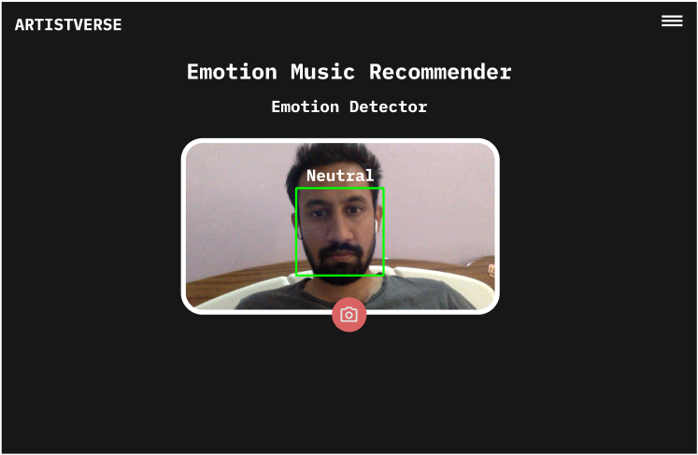
UI-08-2 With system unable to determine the mood
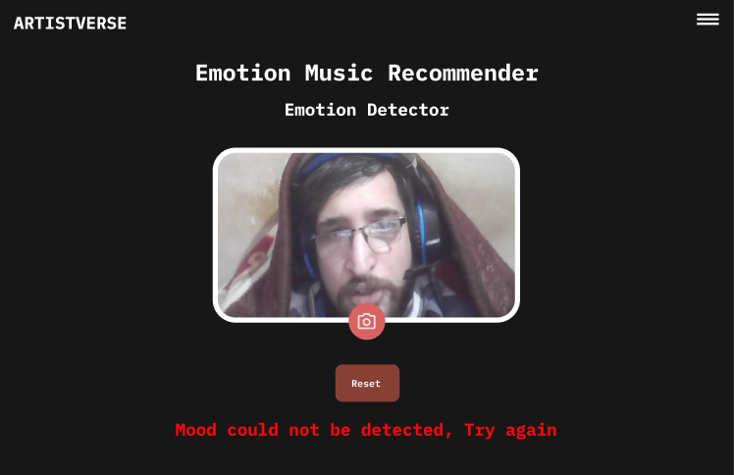
Document  Name | Artistverse-SDD V.3.0 | Owner | NS , WS | Page | 68
Document  Type | Software Design  Development | Release Date | 11/10/2024 | Print date | 11/10/2024

UI-08-3 Camera mood page with detected mood
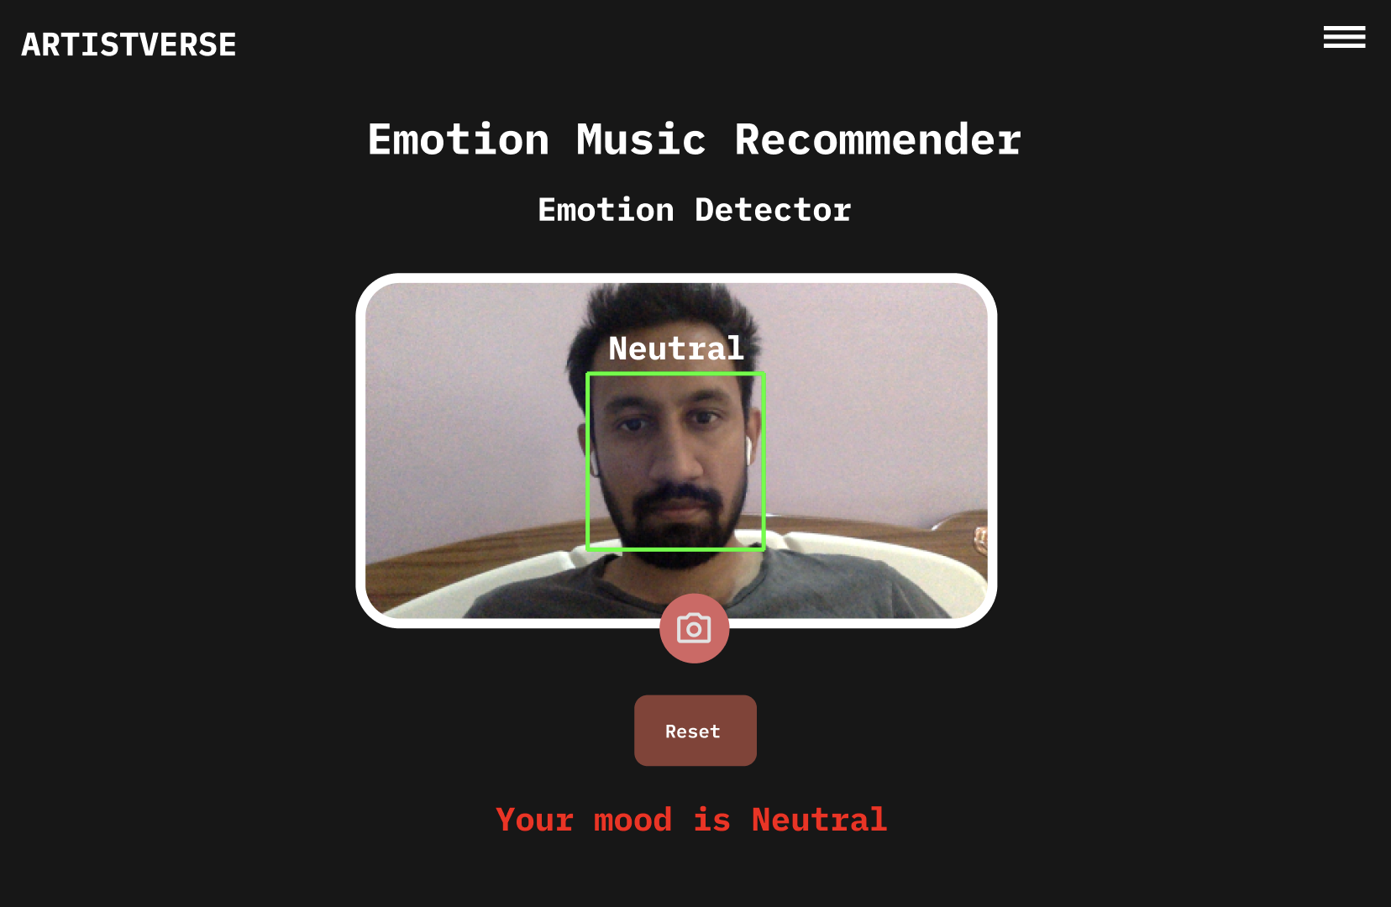
Document  Name | Artistverse-SDD V.3.0 | Owner | NS , WS | Page | 69
Document  Type | Software Design  Development | Release Date | 11/10/2024 | Print date | 11/10/2024

UI-08-4 With song recommended and song choosing
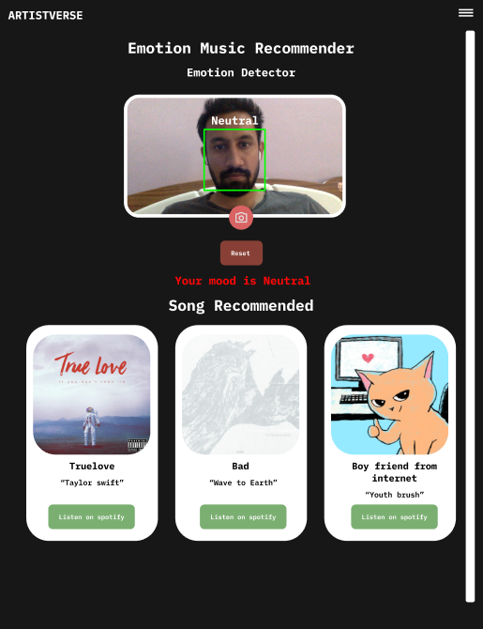
Document  Name | Artistverse-SDD V.3.0 | Owner | NS , WS | Page | 70
Document  Type | Software Design  Development | Release Date | 11/10/2024 | Print date | 11/10/2024

4.2 Progress II
4.2.1 Web Application UI
UI-09 Chord Progression page
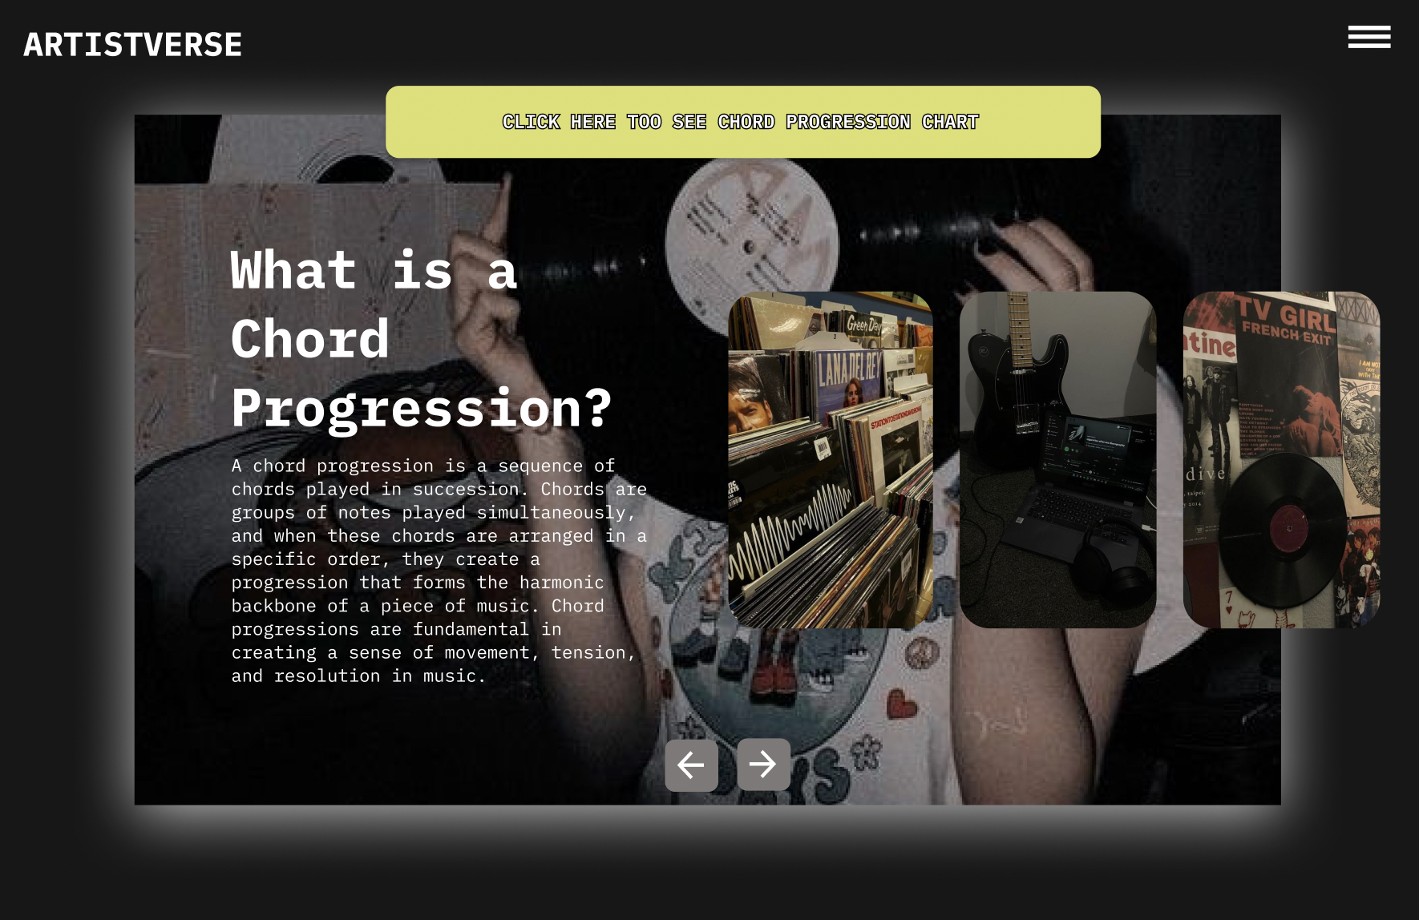
UI-09-1 Chord Progression page when click next button
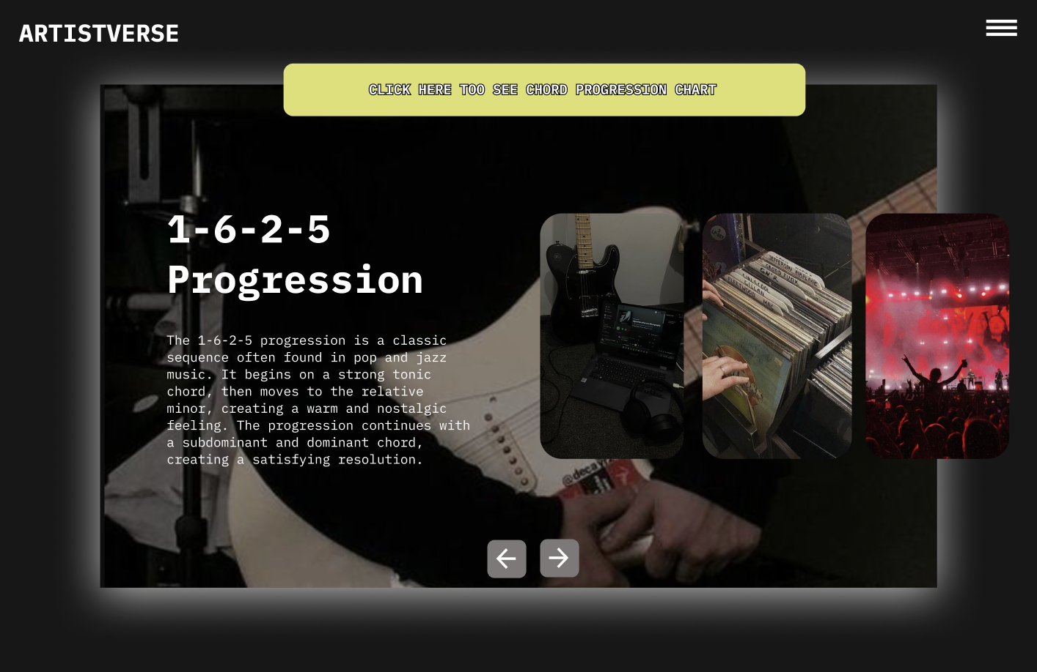
Document  Name | Artistverse-SDD V.3.0 | Owner | NS , WS | Page | 71
Document  Type | Software Design  Development | Release Date | 11/10/2024 | Print date | 11/10/2024

UI-10 Chord Progression Table page
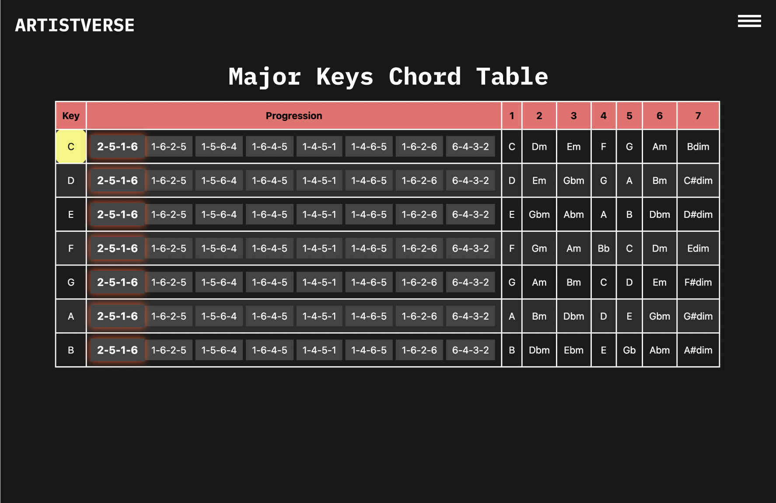
UI-10-1 With selected progression
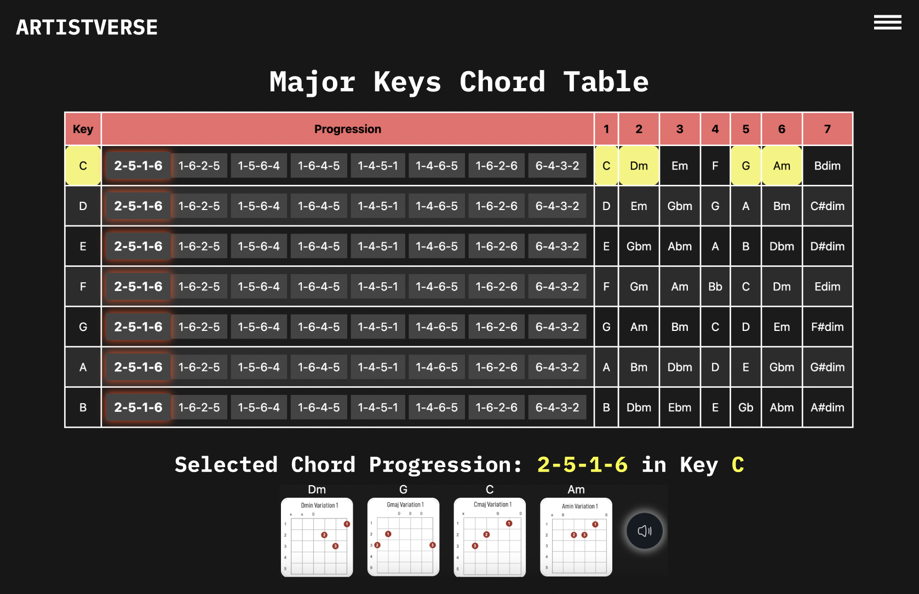
Document  Name | Artistverse-SDD V.3.0 | Owner | NS , WS | Page | 72
Document  Type | Software Design  Development | Release Date | 11/10/2024 | Print date | 11/10/2024

UI-10-2 With highlights the chord in the progression with an orangecolour as the sound it is played.
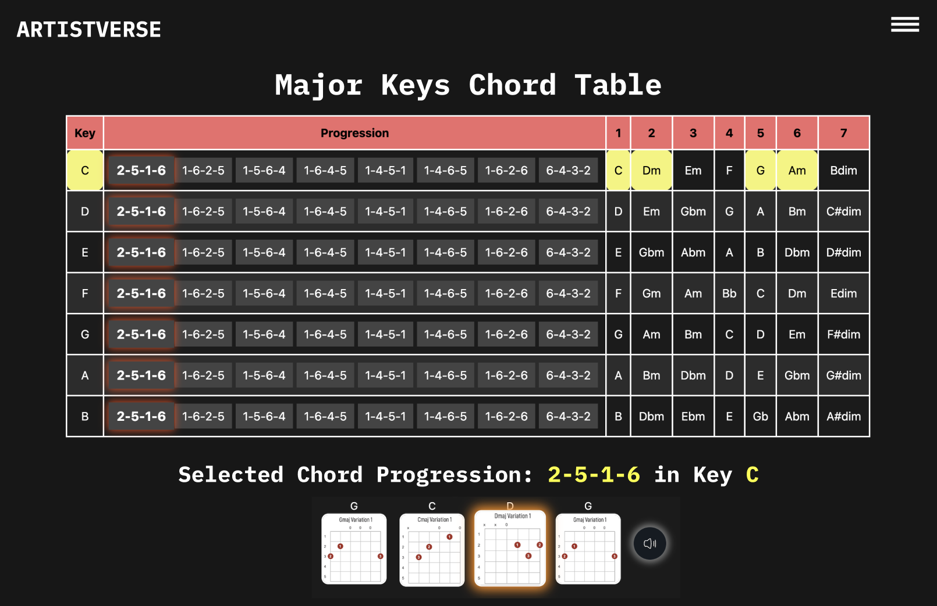
UI-11 AI-Assistance page
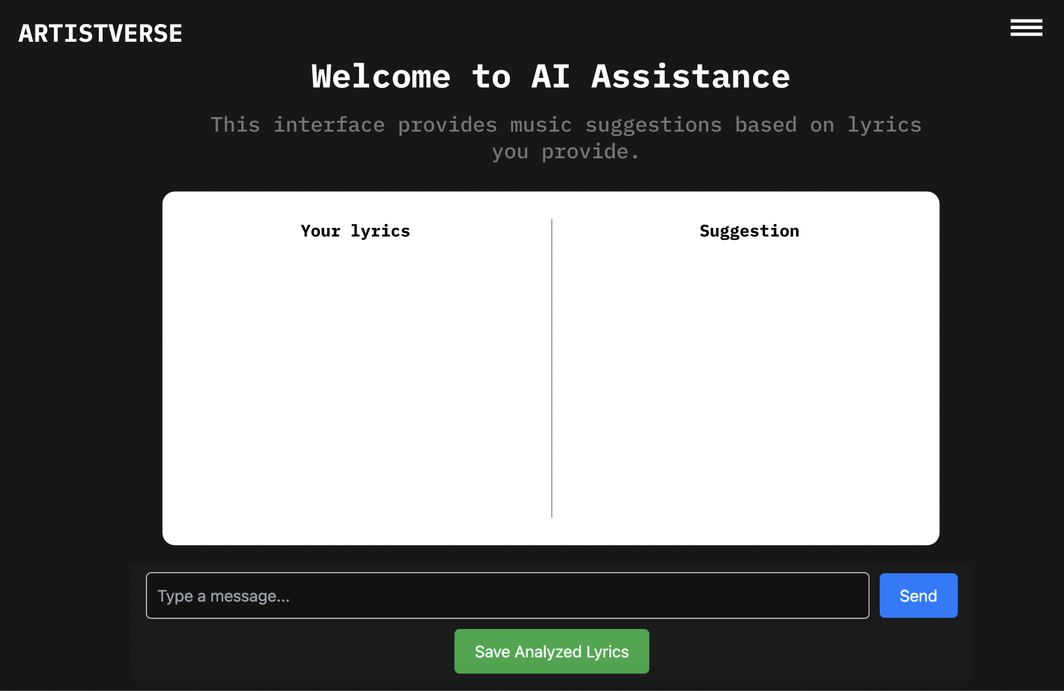
Document  Name | Artistverse-SDD V.3.0 | Owner | NS , WS | Page | 73
Document  Type | Software Design  Development | Release Date | 11/10/2024 | Print date | 11/10/2024

UI-11-1 With invalid input
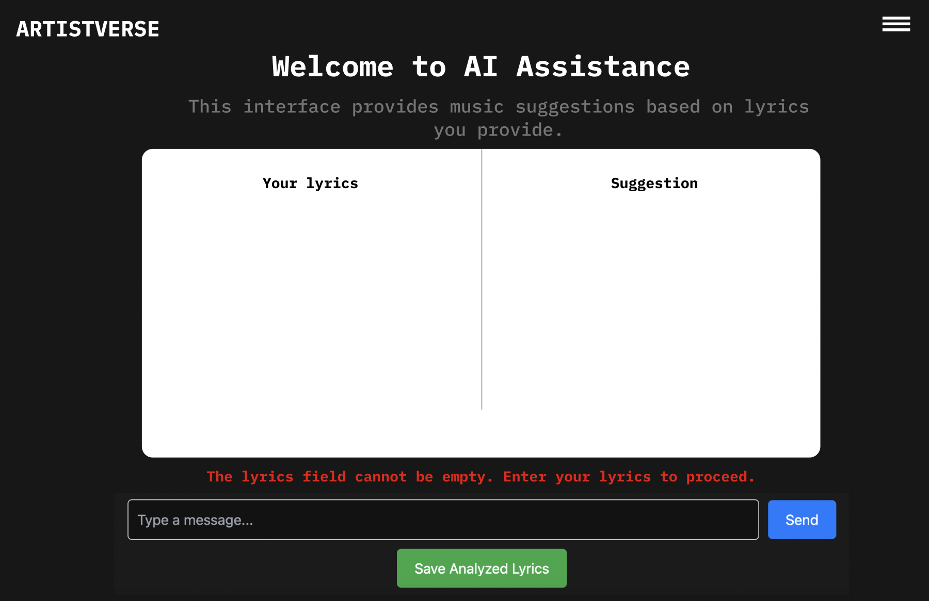
UI-11-2 With User input
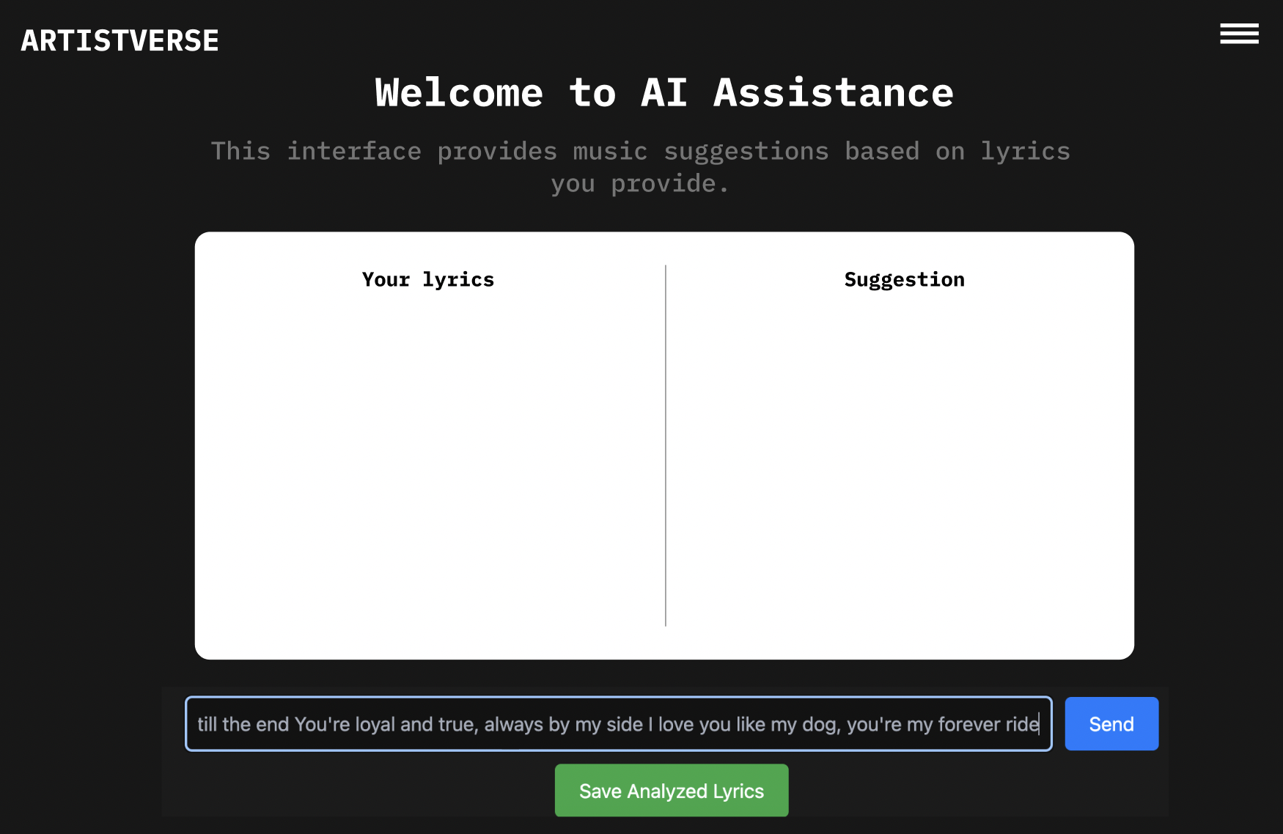
Document  Name | Artistverse-SDD V.3.0 | Owner | NS , WS | Page | 74
Document  Type | Software Design  Development | Release Date | 11/10/2024 | Print date | 11/10/2024

UI-11-3 Proceed without internet connection
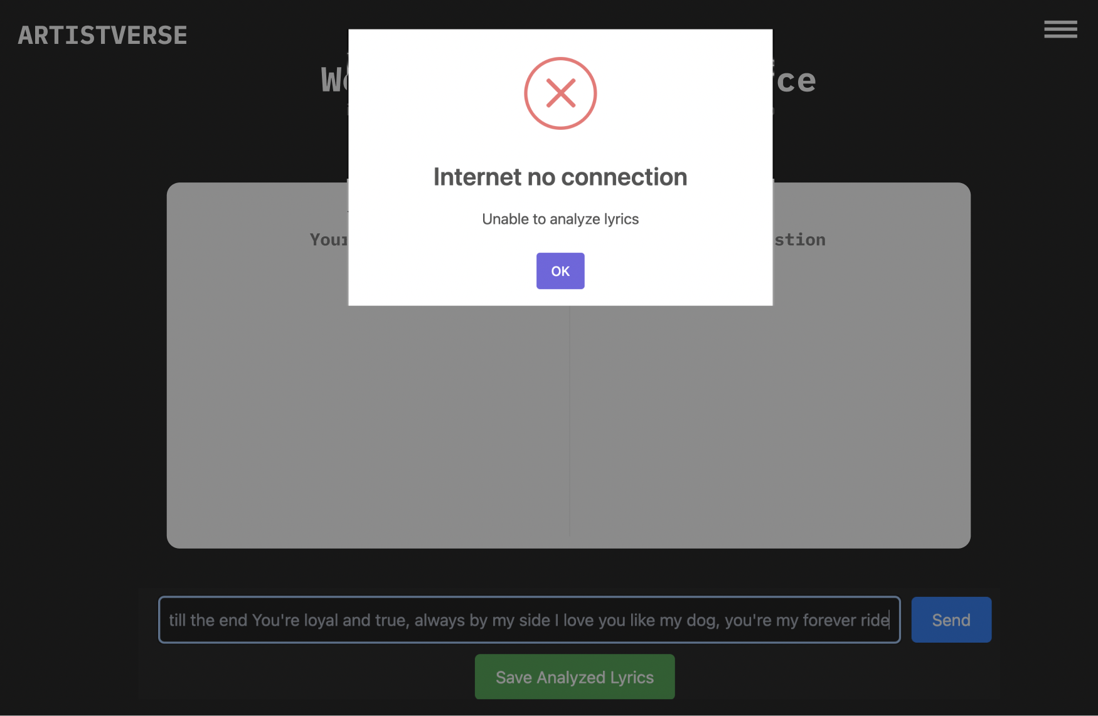
UI-11-4 With input after click button “Send”
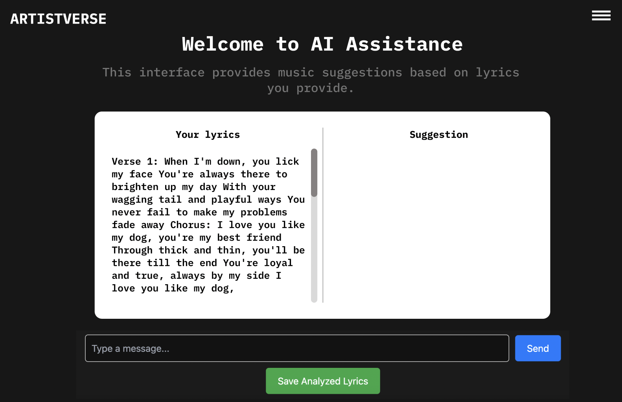
Document  Name | Artistverse-SDD V.3.0 | Owner | NS , WS | Page | 75
Document  Type | Software Design  Development | Release Date | 11/10/2024 | Print date | 11/10/2024

UI-11-5 With suggestion analyzed
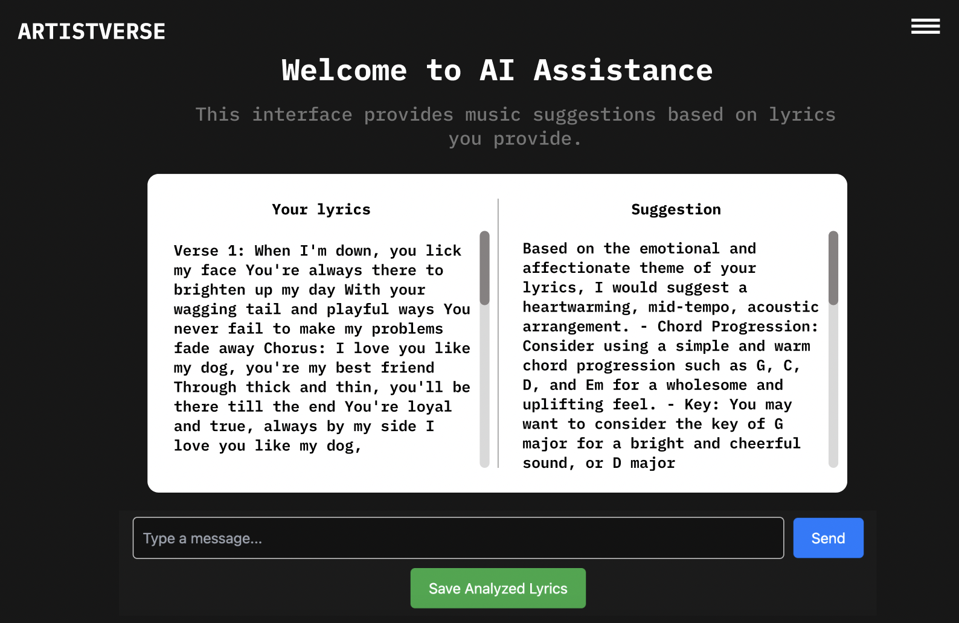
UI-11-6 With User click save analyzed lyrics
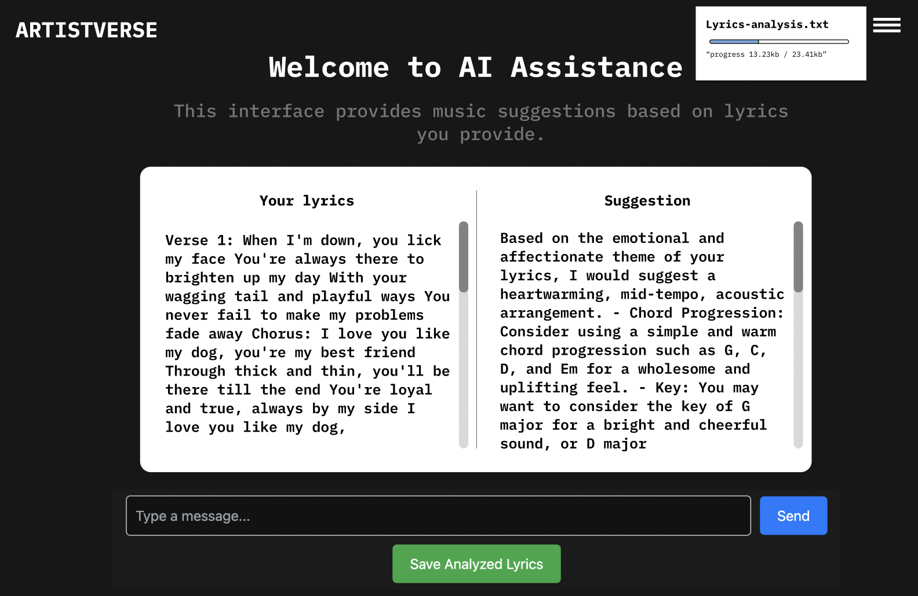
Document  Name | Artistverse-SDD V.3.0 | Owner | NS , WS | Page | 76
Document  Type | Software Design  Development | Release Date | 11/10/2024 | Print date | 11/10/2024

UI-11-7 With no internet connection when clicking “Save AnalyzedLyrics”
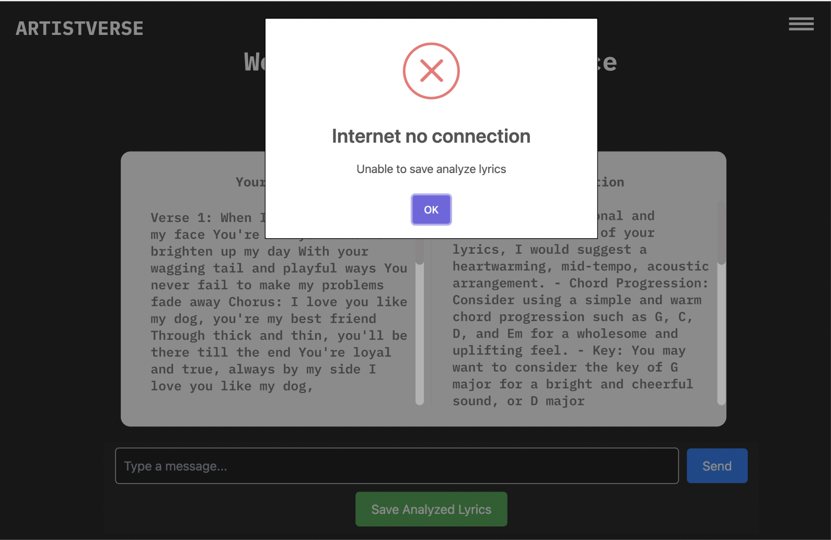
Document  Name | Artistverse-SDD V.3.0 | Owner | NS , WS | Page | 77
Document  Type | Software Design  Development | Release Date | 11/10/2024 | Print date | 11/10/2024

